
KiyaAI Credit Assessment System
BRD_V.1.3
Submitted to – Commercial Bank of Kuwait
Date – 09-12-2025
Table of Contents
1. INTRODUCTION 5
2. PURPOSE 5
3. SCOPE OF THE BRD 6
3.1 In-Scope Functional Areas 6
3.2 Out-of-Scope Areas 7
3.3 Stakeholders 7
3.4 Assumptions 8
3.5 Dependencies 8
4. Features & Functionalities 9
4.1. Login 9
4.2. Dashboard 10
4.3. Rating Templates 12
4.4. Parameters Management 16
4.5. Credit Assessment 52
4.6. Reports 80
4.7. Administration 92
4.7.1. Role Management 92
4.7.2. User Management 94
4.7.3. RBAC (Role-Based Access Control) 97
4.8. Masters 99
4.8.1. Lookup Management 99
4.9. System Configuration 101
5. Data Ingestion 106
6. API Catalogue 116
7. Deployment Mechanism 118
8. Software Pre-requisites 119
8.1. ENVIRONMENT SETUP 119
9. Project Documentation 120

SIGN-OFF
This is the BRD document prepared for the implementation of KiyaAI’s Credit Assessment System at CBK.
For KiyaAI
Prepared By | Reviewed By | Approved By

For CBK
Name | Designation | Signature

We have reviewed this document and agreed that the same is in line with what has been demonstrated, discussed, and finalised between Kiya.ai’s Team and CBK IT and Business Teams. We agree that this document overrides any other documents that have been shared previously.
Please note that the final screens developed may differ slightly from the screen layouts outlined in the BRD, depending on technical feasibility.

✔️ Approval Statement
By signing this document, all parties acknowledge that the requirements described herein are complete to the best of their knowledge and accurately represent the expected functionality of the KiyaAI Credit Assessment System.
This document has been prepared to provide clarity on the deliverables for the KiyaAI Credit Assessment System. However, CBK’s Request for Proposal (RFP) shared during the bidding process remains the primary source for enumerating, interpreting, and assessing the project deliverables. In alignment with the RFP, KiyaAI has mapped all requirements specified therein to the corresponding items in the BRD prepared for sign-off and has shared the consolidated mapping with the Bank in a separate Excel file.
Any modifications post–sign-off must go through the agreed change-control process.

BRD Version
Version | Date | Description | Prepared By | Reviewed By | Approved By
1.0 | 20-Nov-2025 | First version of BRD shared with CBK for review. | Kiya.ai Project Team | CBK Business & IT Team | Mr. Tanveer Munshi
1.1 | 26-Nov-2025 | Updates based on client comments & review inputs. | Kiya.ai Project Team | CBK Business & IT Team | Mr. Tanveer Munshi
1.2 | 01-Dec-2025 | Updates based on client comments & review inputs. | Kiya.ai Project Team | CBK Business & IT Team | Mr. Tanveer Munshi
1.3 | 09-Dec-2025 | Updates based on client comments & review inputs. | Kiya.ai Project Team | CBK Business & IT Team | Mr. Tanveer Munshi

1. INTRODUCTION
The KiyaAI Credit Assessment System is a comprehensive digital platform designed to automate and enhance the credit evaluation process for financial institutions. The system provides a structured workflow for assessing borrowers by leveraging configurable rating templates, parameter-based scoring, financial analysis, automated ratio calculations, OCR-based data ingestion, and AI-driven insights.
The platform supports end-to-end credit assessment activities, including data collection, template management, parameter configuration, risk scoring, report generation, user management, system configuration, and audit tracking. It ensures consistency, transparency, and regulatory compliance in the credit evaluation lifecycle.
This Business Requirements Document (BRD) defines the detailed functional, non-functional, operational, and user-interface requirements required to implement the system in alignment with business expectations.

2. PURPOSE
The purpose of this BRD is to:
- Document all functional and operational requirements for the KiyaAI Credit Assessment System.
- Provide a detailed understanding of screens, workflows, user roles, system processes, data flows, APIs, and infrastructure needs.
- Establish a single source of truth for stakeholders including:
  - Product Owners
  - Business Analysts
  - Technical Architects
  - Developers
  - QA Teams
  - End Users
  - Implementation & Deployment Teams
- Define expected behaviors of each module to ensure:
  - Consistency in development
  - Clarity for UI/UX teams
  - Precision for backend/API development
  - Alignment with regulatory and business objectives
- Bridge the gap between business expectations and technical implementation by clearly articulating:
  - Use cases
  - Flows
  - Acceptance criteria
  - Dependencies
The BRD ensures that all teams have a unified understanding of what the system must deliver and how it should function.

3. SCOPE OF THE BRD
The scope of this BRD includes documenting the full set of business and system requirements for the design, development, deployment, and operation of the KiyaAI Credit Assessment System.

3.1 In-Scope Functional Areas
This BRD covers detailed requirements for the following modules:
A. Core User Modules
- Login & Authentication
- Dashboard & Analytics
- Credit Assessment Module
  - Entity details
  - Financial data capture (manual + OCR + file upload)
  - Ratio calculations
  - Business and qualitative scoring
  - Final rating computation
  - Maker-checker approvals (if applicable)
- Rating Templates Management
- Parameters Management
- Reports & Document Generation
B. Administrative Modules
- Role Management
- User Management
- RBAC (Role-Based Access Control)
- Master Data Management
  - Country, State, City
  - Lookup management
- System Configurations
  - Email settings
  - Email templates
  - Module management
C. Data Management Modules
- Data Ingestion
  - Financial data ingestion
  - OCR processing
  - Excel/CSV file processing
  - Data validation
  - Gaps identification
D. Technical & Deployment Scope
- API Catalog
  - Internal APIs
  - Expected third-party integrations
- Deployment & Infrastructure Requirements
  - Hosting
  - Database (Oracle)
  - Software prerequisites
- System Documents
  - FSD
  - User Manual
  - Deployment Guide

3.2 Out-of-Scope Areas
The following items are outside the scope of this BRD unless otherwise requested:
- Enterprise LOS integration (Loan Origination System)
- Credit Bureau API integrations (unless added as per customer requirement)
- Mobile application development
- Advanced ML risk modeling
- Automated underwriting engine
- Third-party compliance validation tools

3.3 Stakeholders
- Business Team – Defines assessment rules, workflows, templates
- IT Team – Infrastructure, security, deployment
- Development Team – UI, backend, APIs
- QA Team – Testing and validations
- Operations Users – Credit analysts, approvers
- Administrators – Role, user and system configuration

3.4 Assumptions
- The system will run on a secure network with HTTPS enabled.
- Oracle Database will be available as the primary data source.
- All users will be authenticated using username/password unless SSO is enabled in future.
- Master data will be provided prior to UAT.

3.5 Dependencies
- Availability of financial data input formats.
- Integration availability for OCR engine.
- Access control rules provided by business team.
- Email server configuration details.

4. Features & Functionalities

4.1. Login
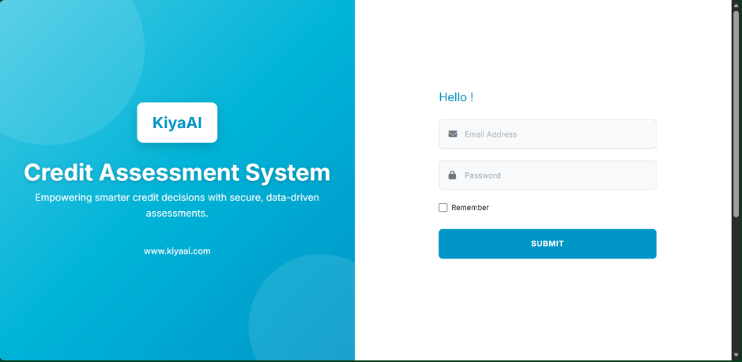
The Login module provides secure entry into the KiyaAI Credit Assessment System. Users can authenticate either through ADS (Active Directory Services) or through Manual Login using email and password. The objective is to ensure only authorized users gain access to the system.
The Login screen contains:
- Left Panel → Welcome branding, logo, product title
- Right Panel → Login form
- Fields:
  - Email
  - Password
  - Remember Me
- Buttons:
  - Login
  - ADS Login (if enabled)
- Error Display: Invalid credential banner
- Fully responsive layout
Manual Login
- User enters Email + Password.
- System validates format and required fields.
- Authentication request sent to backend.
- On success → dashboard loads.
- On failure → error message shown with shake animation.

ADS Login
- User clicks "Login with ADS".
- System redirects to configured ADS/SSO endpoint.
- ADS validates user credentials.
- On success → system receives user profile & roles.
- User is logged into the application without manual credential entry.

Security
- All credentials transmitted over HTTPS (If SSL Certificate implemented).
- Invalid attempts logged in audit trail.
- User session managed via token-based authentication.
- Logout clears token and session.

4.2. Dashboard
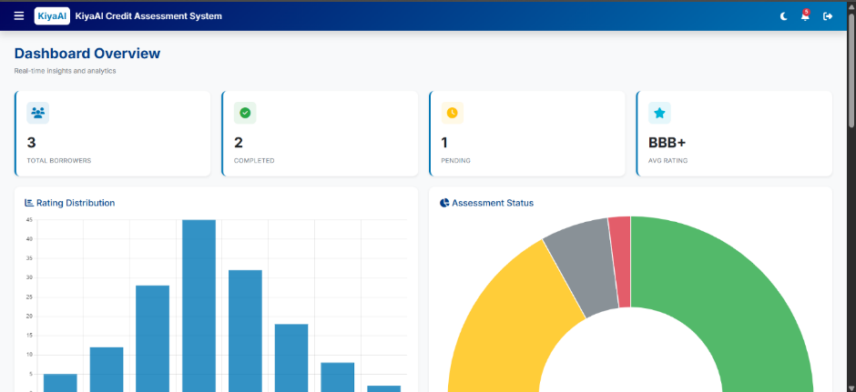

The Dashboard provides a real-time overview of credit assessment activities, borrower statistics, rating outcomes, and workflow status. It acts as the user’s landing page after login and presents high-level operational insights.
The Dashboard contains the following key UI elements:
A. Summary Cards
- Total Borrowers
- Completed Assessments
- Pending Assessments
- Average Rating
B. Charts & Analytics
- Rating Distribution (Bar Chart)
- Assessment Status Distribution (Pie Chart)
- Monthly Assessment Trend (Line Chart)
C. Recent Assessments Table
- ID
- Entity Name
- Template
- Date
- Status
- Rating
- Quick Actions: Edit, Tag CIF, 360° View
A “New Assessment” button is also available to directly start the assessment workflow.

FUNCTIONAL DETAILS
Summary Statistics
- Fetches aggregated data from backend services.
- Auto-refresh on page load.
- Reflects live assessment counts and performance indicators.
Charts
- Rating Distribution: Shows number of entities per rating grade.
- Assessment Status Chart: Displays Pending / Completed / Draft statuses.
- Trend Chart: Monthly count of assessments over the selected period.
Charts help users understand portfolio risk patterns and workloads.
Recent Assessments
- Displays latest assessment records.
- Sortable and supports quick navigation to Edit/View.
- “New Assessment” initiates Step-1 of the Assessment Module.
- 360° customer view button opens consolidated customer profile (if implemented).
- Records show status badges (Draft, Pending, Completed).
User Actions
- Navigate to Assessment Module
- Continue editing previous assessments
- Tag CIF to assessments lacking customer linkage
- Trigger analytics or 360° views
Client Additions –
- Dashboard/Landing Page must show each case with:
  - Current workflow stage
  - Status indicators
- Helps users track assessment stage quickly.

4.3. Rating Templates
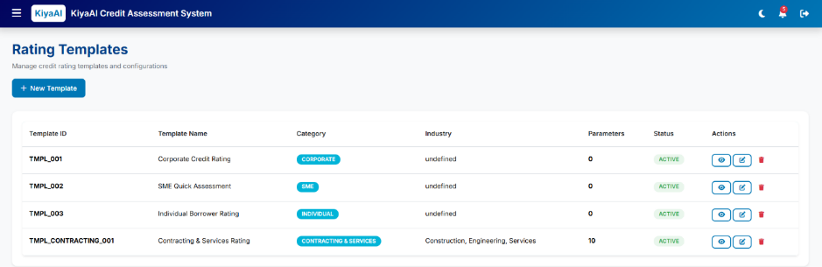

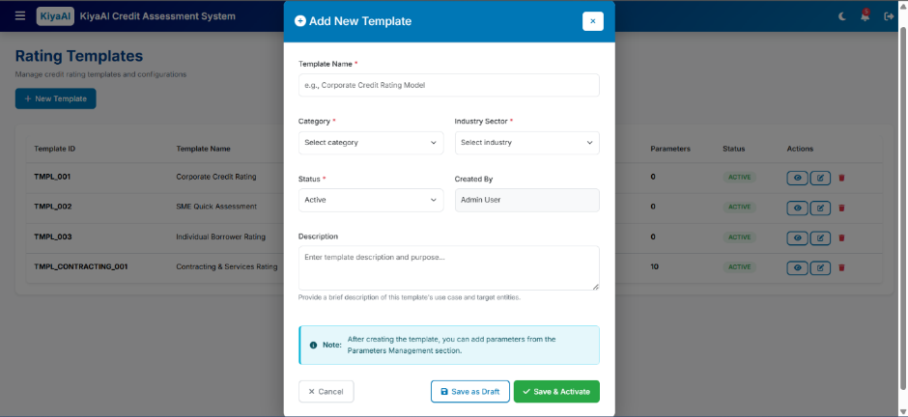

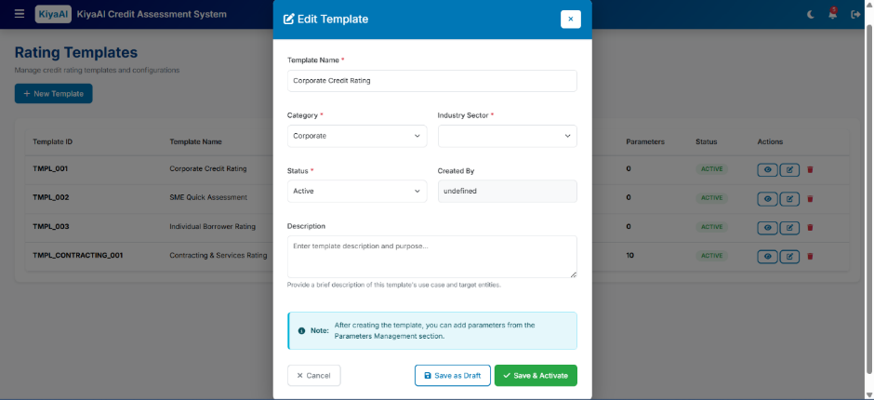

The Rating Templates module allows administrators and credit analysts to create, configure, and manage rating templates used during credit assessment.
Each template defines the structure of parameters, categories, weights, and industry applicability.
The Templates screen contains:
A. Template List Table
Columns include:
- Template ID
- Template Name
- Category (Corporate, SME, Real Estate, etc.)
- Industry
- Parameter Count
- Status (Active / Draft / Inactive)
- Actions (Edit, Activate/Deactivate)
B. Header Actions
- New Template button opens the Add/Edit Template Modal.
C. Add/Edit Template Modal
Includes fields:
- Template Name
- Category
- Industry
- Status
- Created By
- Description
- Save as Draft / Save & Activate buttons
The modal also displays a note that parameters can be added from the Parameters module after template creation.
FUNCTIONAL DETAILS
Create Template
- User clicks New Template.
- Modal opens to input mandatory fields.
- On save:
  - If “Save as Draft” → Template saved as Draft.
  - If “Save & Activate” → Template becomes Active.
- System records:
  - Creator
  - Creation timestamp
  - Status
Templates cannot be used in assessments unless status = Active.

Edit Template
- Selecting “Edit” from the table opens the modal pre-filled.
- Editable fields:
  - Name
  - Category
  - Industry
  - Description
  - Status
- Updating an Active template may require versioning (based on customer requirement).

Template Status Management
Statuses:
- Active → Available for assessments
- Draft → Editable, not usable
- Inactive → Archived, not selectable
Status changes will be logged in the audit trail.

Template-Parameter Linkage
- Templates define structure only.
- Parameters (weights, formulas, qualitative options) are configured in the Parameters Module.
- Each template may have multiple parameters grouped by categories.
Templates Modal’s System will have, as per the client's shared data –
1. Contracting & Service Template
2. Trading & Manufacturing Template
3. Investment Real estate & finance
4. Personal Net Worth Declaration Borrowers Grading

Client Additions –
4.3.x Template Associations & Auto-Selection Enhancements
- Multi-Select Category & Sector Mapping
  - Rating Templates must support:
    - Multi-select Categories
    - Multi-select Industry Sectors
  - Admin can assign a single template to multiple sectors & categories.
- Auto-Selection of Rating Model
  - During assessment, the Rating Model/template must be automatically selected based on:
    - Entity Type
    - Industry Sector
  - If user chooses a different template, system must display a warning prompt stating recommended template and allowing override.

4.4. Parameters Management
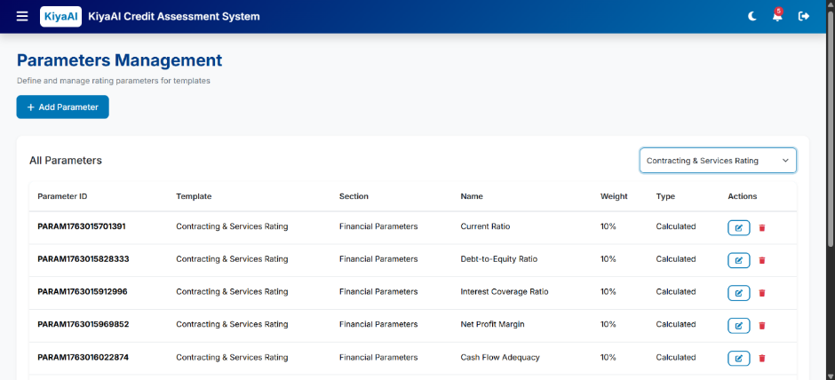

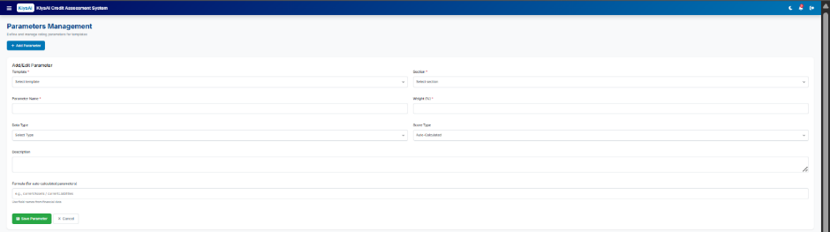

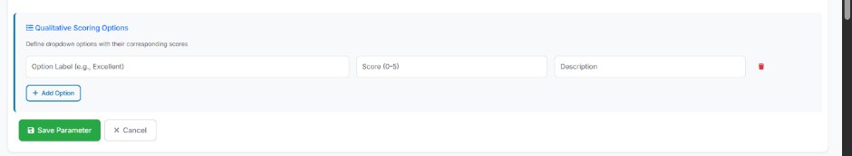

The Parameters Management module allows administrators to define, configure, and maintain scoring parameters used inside rating templates.
Each parameter contributes to the overall credit score through weights, formulas, scoring methods, or qualitative options.
This module ensures consistency and flexibility in rating model configuration.
The screen consists of:
A. Parameter List Table
Columns:
- Parameter ID
- Template Name
- Section (Financial / Business / Risk)
- Parameter Name
- Weight %
- Type (Ratio / Percentage / Number / Qualitative / Score)
- Actions (Edit/Delete)
B. Header Action
- Add Parameter button → opens Parameter Form
C. Parameter Form (Add/Edit)
Fields include:
- Template
- Section
- Parameter Name
- Weight (%)
- Data Type
- Score Type (Auto / Manual)
- Description
- Formula (for auto-calculated parameters)
- Qualitative Options Section (dynamic fields)
Visibility:
- Qualitative section appears only when Data Type = Qualitative.
FUNCTIONAL DETAILS
Add Parameter
- User selects template & section.
- Enters parameter details including:
  - Name
  - Weight
  - Type
  - Description
  - Formula (optional)
- If Data Type is Qualitative, user adds:
  - Options
  - Score for each option
- Save stores parameter under selected template.

Edit Parameter
- Opens the form with existing parameter data.
- Allows modification of:
  - Weight
  - Description
  - Formula
  - Options (if qualitative)
- Template link may be restricted for editing (based on configuration rules).

Parameter Types
- Ratio → Formula-based computation
- Percentage → Numeric input
- Number → Raw numeric values
- Score (1–5) → Manual or auto
- Qualitative → Dropdown with score mapping

Weight Validation
- Total weight across all parameters for a template must sum up to 100%.
- System must:
  - Warn user on exceeding
  - Block save if invalid

Parameter-Template Relationship
- One template → Multiple parameters
- Parameters grouped by:
  - Financial Parameters
  - Business Parameters
  - Risk Parameters
Displayed in assessment steps accordingly.

Data Binding
- Parameters influence:
  - Ratio calculations
  - Business scoring
  - Final rating outcome
Values captured during assessment populate these parameters.

Parameters as per shared data
1. Contracting & Service Template
✅ 1. Customer Financial Information Table
Sr. No | Parameter | Description
1 | Revenue | Annual revenue of the customer
2 | Cost of Goods Sold | Direct cost of goods sold
3 | Net Profit | Profit after all expenses
4 | Total Current Assets | Sum of short-term assets
5 | Affiliates Due | Amount due from affiliates
6 | Investment Assets | Financial investment assets
7 | Total Assets | Total assets (current + non-current)
8 | Total Current Liabilities | Current obligations
9 | Total Debt | Total CL + Long-term liabilities
10 | Total Bank Borrowings | Total outstanding bank loans
11 | Total Liabilities incl. Owner’s Funds | Overall liabilities
12 | Net Worth | Shareholders' equity
13 | Operating Cash | Operating cash flow

✅ 2. Non-Financial Information Table
Sr. No | Parameter | Description
1 | Constitution and Establishment | Type of entity & incorporation details
2 | Number of Years in Business | Business age
3 | Unutilized Credit Limits | Available unused credit with lenders
4 | Financial Planning & Control | Risk management & internal audit practices
5 | Position in the Market | Competitive standing
6 | Govt./Private Contracting | Type of client portfolio
7 | Sensitivity to Economic Shocks | Stability against external disruptions
8 | Contractor/Subcontractor Grade | Classification/grading of contractor
9 | Past Track Record | History of service delivery
10 | Competition & Demand | Industry competition intensity
11 | Qualified Resources & Management | Availability of skilled human and physical resources

✅ 3. Mandatory Adjustments Table
Parameter | Description
Age of Financial Information | Recency of financial statements
Quality of Financial Information | Reliability, audit quality
Historical Account Performance | Customer repayment history
Qualification of Audit Report | Whether audit report has qualifications

✅ 4. Discretionary Overrides Table (Complete Professional Version)
Category | Override Reason | Max Upgrade | Max Downgrade
GEN | Management changes | 2 | 2
GEN | Change in Regulation | 1 | 1
GEN | Length of relationship – Strong / Weak | 1 | 1
GEN | External Relationship (Part of strong group / troubled group) | 1 | 1
GEN | Deposit availability / Ancillary business | 1 | 0
GEN | Bankruptcy, Liquidation | 0 | 3
GEN | Deterioration of group accounts exposure | 0 | 2
GEN | Unresolved conflict between owners | 0 | 2
GEN | Death of a key person | 0 | 2
GEN | Non-existence of succession plan | 0 | 1
FIN | Income Diversification | 1 | 1
BUSS. PERF | Strategic contract signed / loss of key contract | 2 | 2
BUSS. PERF | Change in Market Position | 2 | 2
BUSS. PERF | Performance vs. Budget (better/worse) | 1 | 1
BUSS. PERF | Reputation (Strong / Poor) | 1 | 1
LEGAL | Ongoing legal dispute / Court order | 0 | 2
ECONOMIC | Drastic fall in capital markets | 0 | 1
ECONOMIC | Drastic fall in oil prices | 0 | 1
ECONOMIC | Global economic deterioration | 0 | 2
POLITICAL | Social disturbances / unrest | 0 | 1
ASSIGNMENT | 100% Govt. sector contracts with legal assignment | 2 | 0
ASSIGNMENT | Majority contracts (>75%) with strong assignment | 1 | 0
ASSIGNMENT | >50% contracts without credible assignment | 0 | 1
Account Conduct | Persistent ever-greening (>2 years) | 0 | 1

Qualitative Factor – Relative Risk Ordering - Score
F1 — Constitution and Establishment
Range | Relative Risk Order | Score
Government / Semi-government | 1 | 29
Public Shareholding Companies | 2 | 22
Closed Shareholding Companies | 3 | 15
Partnership with >50% ownership / Sole Proprietorship | 4 | 7
Other Partnership or Establishment | 5 | 0

F2 — Number of Years in Business
Range | Relative Risk Order | Score
More than 20 years | 1 | 29
10 – 20 years | 2 | 22
2 – 10 years | 3 | 11
Less than 2 years | 4 | 0

F3 — Availability of Unutilized Credit Lines
Range | Relative Risk Order | Score
Available & utilized < 20% | 1 | 29
Available & utilized 20–70% | 2 | 22
Sole Bank | 3 | 15
Available & utilized > 70% | 4 | 7
Over-utilization beyond limits | 5 | 0

F4 — Financial Planning & Internal Control
Range | Relative Risk Order | Score
Not Applicable | 0 | 23
Good | 1 | 27
Moderate | 2 | 18
No financial planning & control | 3 | 9

F5 — Position in the Market
Range | Relative Risk Order | Score
Market Leaders | 1 | 29
Strong Position | 2 | 22
Below Average | 3 | 11
New Entrant | 4 | 0

F6 — Govt. / Private Sector Contracting
Range | Relative Risk Order | Score
Not Applicable (Neutral Score) | 0 | 23
100% Govt. / Public Sector | 1 | 29
>75% Govt. / Public Sector | 2 | 22
>50% Govt. + strong private | 3 | 15
Majority private – net worth known | 4 | 7
Majority private – net worth unknown | 5 | 0

F7 — Sensitivity to Economic Shocks
Range | Relative Risk Order | Score
Unlikely to be affected | 1 | 29
Minor impact | 2 | 22
Likely to see impact | 3 | 11
Highly sensitive | 4 | 0

F8 — Contractor / Subcontractor Grade
Range | Relative Risk Order | Score
Not Applicable (Service Companies) | 0 | 23
Grade I | 1 | 26
Grade II | 2 | 22
Grade III | 3 | 17
Grade IV / Ungraded | 4 | 12

F9 — Past Track Record
Range | Relative Risk Order | Score
Not Applicable | 0 | 23
Excellent | 1 | 31
Good | 2 | 21
Average | 3 | 7
Poor | 4 | -8

F10 — Competition & Demand
Range | Relative Risk Order | Score
Low competition & high demand | 1 | 29
High competition & high demand | 2 | 22
Low competition & low demand | 3 | 11
High competition & low demand | 4 | 0

F11 — Resource & Management Capability
Range | Relative Risk Order | Score
Well Qualified | 1 | 33
Partially Qualified | 2 | 9
Not adequately qualified | 3 | -14

Quantitative Factors
✅ MASTER FINANCIAL RATIO SCORING TABLE
1. AffDueToNW (Affiliates Due to Net Worth Ratio)
Measures: How much affiliates owe compared to company’s net worth.
Label | From | To | Points
AffDueToNW < 0.01 | -9999 | 0.01 | 33
0.01 ≤ AffDueToNW < 0.1 | 0.01 | 0.1 | 25.6
0.1 ≤ AffDueToNW < 0.2 | 0.1 | 0.2 | 21
0.2 ≤ AffDueToNW < 0.66 | 0.2 | 0.66 | 15.5
AffDueToNW ≥ 0.66 | 0.66 | 9999 | 13.6

2. Current Ratio
Formula: Current Assets / Current Liabilities
Higher = safer liquidity.
Label | From | To | Points
CurrentRatio < 0.78 | 0 | 0.78 | 7.1
0.78 ≤ CurrentRatio < 0.96 | 0.78 | 0.96 | 9.5
0.96 ≤ CurrentRatio < 1.1 | 0.96 | 1.1 | 11.9
1.1 ≤ CurrentRatio < 1.47 | 1.1 | 1.47 | 15.7
1.47 ≤ CurrentRatio < 2.96 | 1.47 | 2.96 | 27.1
2.96 ≤ CurrentRatio < 5.38 | 2.96 | 5.38 | 34
CurrentRatio ≥ 5.38 | 5.38 | 9999 | 41.2

3. Debt Equity Ratio (DER)
Formula: Total Debt / Net Worth
Lower = safer.
Label | From | To | Points
DER < 0.16 | -9999 | 0.16 | 41
0.16 ≤ DER < 0.42 | 0.16 | 0.42 | 33.9
0.42 ≤ DER < 1.06 | 0.42 | 1.06 | 21.5
1.06 ≤ DER < 1.48 | 1.06 | 1.48 | 18.9
1.48 ≤ DER < 1.93 | 1.48 | 1.93 | 14.5
1.93 ≤ DER < 4 | 1.93 | 4 | 10
DER ≥ 4 | 4 | 9999 | 7.4

4. OpsRev/ExtLiab (Operating Revenue / External Liabilities)
Higher = better repayment capacity.
Label | From | To | Points
< -1.6 | -9999 | -1.6 | 1.8
-1.6 ≤ x < -0.4 | -1.6 | -0.4 | 6.8
-0.4 ≤ x < -0.15 | -0.4 | -0.15 | 11.8
-0.15 ≤ x < -0.03 | -0.15 | -0.03 | 16.8
-0.03 ≤ x < 0.03 | -0.03 | 0.03 | 21.8
0.03 ≤ x < 0.13 | 0.03 | 0.13 | 26.8
0.13 ≤ x < 0.45 | 0.13 | 0.45 | 31.8
0.45 ≤ x < 2.1 | 0.45 | 2.1 | 36.8
≥ 2.1 | 2.1 | 9999 | 41.8

5. InvAssetsToTA (Investment Assets to Total Assets)
Label | From | To | Points
< 0.09 | 0.01 | 0.09 | 31
0.09 ≤ x < 0.24 | 0.09 | 0.24 | 19.1
0.24 ≤ x < 0.64 | 0.24 | 0.64 | 10
≥ 0.64 | 0.64 | 1.5 | 6.7

6. Net Profit Margin
Label | From | To | Points
< 0 | -9999 | 0 | 14.9
0 ≤ x < 0.06 | 0 | 0.06 | 18.8
0.06 ≤ x < 0.21 | 0.06 | 0.21 | 26.9
≥ 0.21 | 0.21 | 9999 | 35.2

7. WCT (Working Capital Turnover / Working Capital to Turnover)
Higher = better working capital health.
Label | From | To | Points
< -0.48 | -9999 | -0.48 | 11.8
-0.48 ≤ x < 0 | -0.48 | 0 | 14.4
0 ≤ x < 0.41 | 0 | 0.41 | 17
0.41 ≤ x < 1.2 | 0.41 | 1.2 | 23.1
1.2 ≤ x < 1.88 | 1.2 | 1.88 | 27.5
1.88 ≤ x < 4.52 | 1.88 | 4.52 | 31.8
≥ 4.52 | 4.52 | 9999 | 33.6

8. d_DebtRatio (Change in Debt Ratio)
Measures: how much debt increased or decreased YoY.
Label | From | To | Points
< -0.2 | -9999 | -0.2 | 40.4
-0.2 ≤ x < -0.11 | -0.2 | -0.11 | 31.3
-0.11 ≤ x < 0.33 | -0.11 | 0.33 | 20.5
≥ 0.33 | 0.33 | 9999 | 12.3

2. Investment Real estate & finance Template
✅ 1. FINANCIAL INFORMATION TABLE
Sr. No | Parameter | Description
1 | Balance Sheet Info | Summary of assets, liabilities & equity
2 | Gross Profit | Revenue – COGS
3 | General & Administrative Expenses | Non-operating and administrative costs
4 | Interest | Interest expense on borrowings
5 | Net Profit | Profit after all expenses
6 | Inventory | Total inventory held
7 | Total Current Assets | Short-term assets
8 | Total Assets | All assets combined
9 | Total Current Liabilities | Short-term liabilities
10 | Total Long Term Liabilities | Long-term debt obligations
11 | Current Debt | Short-term debt obligations
12 | Total Debt | Current CL + LT Liabilities
13 | Total Liabilities incl. Owner’s Funds | Overall obligations including capital
14 | Total Bank Borrowings | Total outstanding from banks
15 | Unquoted Asset | Non-listed investments
16 | Unrealized Gains | Gains not yet realized
17 | Operating Cash | Cash generated from operations
18 | Net Worth | Shareholders' equity

✅ 2. NON-FINANCIAL INFORMATION TABLE
Sr. No | Parameter | Description
1 | Constitution & Establishment | Business type & incorporation
2 | Management Character / Style | Leadership credibility & governance
3 | Number of Years in Business | Tenure & experience
4 | Availability of Unutilized Credit Lines | Unused credit from other lenders
5 | Financial Planning & Control | Internal audit & risk management quality
6 | Asset Quality – Investment Diversification | Diversification of investment assets
7 | Asset Quality – Investment Risk | Risk profile of investment assets
8 | Asset Quality – Real Estate Concentration | Concentration & type of real estate assets

✅ 3. MANDATORY ADJUSTMENTS TABLE
Sr. No | Parameter | Description
1 | Age of Financial Information | Recency of financial statements
2 | Quality of Financial Information | Reliability & audit quality
3 | Historical Account Performance | Past repayment history
4 | Qualification of Audit Report | Nature of audit qualifications

✅ 4. DISCRETIONARY OVERRIDES TABLE (DETAILED & PROFESSIONAL)
Class | Override Reason | Max Upgrade | Max Downgrade
GEN | Management changes | 2 | 2
GEN | Change in Regulation | 1 | 1
GEN | Length of relationship – strong/weak | 1 | 1
GEN | External relationship – strong group / troubled group | 1 | 1
GEN | Deposit availability / ancillary business | 1 | 0
GEN | Bankruptcy, Liquidation | 0 | 3
GEN | Deterioration of other group exposures | 0 | 2
GEN | Unresolved conflict between owners | 0 | 2
GEN | Death of a key person | 0 | 2
GEN | No succession plan | 0 | 1
FIN | Income diversification | 1 | 1
BUSS. PERF | Strategic contract signed / loss of contract | 2 | 2
BUSS. PERF | Change in market position | 2 | 2
BUSS. PERF | Performance vs budget (better/worse) | 1 | 1
BUSS. PERF | Reputation (Good/Poor) | 1 | 1
LEGAL | Ongoing legal dispute / court order | 0 | 2
ECONOMIC | Drastic fall in capital markets | 0 | 1
ECONOMIC | Drastic fall in oil prices | 0 | 1
ECONOMIC | Global economic deterioration | 0 | 2
POLITICAL | Social disturbances / uprisings | 0 | 1
ACCOUNT CONDUCT | Persistent evergreening (>2 years) | 0 | 1

Qualitative Factor – Relative Risk Ordering - Score
Factor ID | Factor Name | Factor Details | Relative Risk Ordering | Score
F1 | Constitution and Establishment | Government / Semi-government | 1 | 50
 |  | Public Shareholding Companies | 2 | 38
 |  | Closed Shareholding Companies | 3 | 25
 |  | Partnership (with >50% owner guarantee) / Sole Proprietorship | 4 | 13
 |  | Other Partnership or Establishment | 5 | 0
F2 | Management Character / Style | Risk Conservative Management Approach | 1 | 50
 |  | Moderate & Controlled Risk Taking | 2 | 38
 |  | High Risk Taker (with analysis & provisions) | 3 | 19
 |  | Very High Risk Taker (no analysis) | 4 | 0
F3 | Number of Years in Business | More than 20 years | 1 | 50
 |  | 10–20 years | 2 | 38
 |  | 2–10 years | 3 | 19
 |  | Less than 2 years | 4 | 0
F4 | Availability of Unutilized Credit Lines | Lines available, utilization <20% | 1 | 50
 |  | Lines available, utilization 20–70% | 2 | 38
 |  | Sole Bank | 3 | 25
 |  | Lines available, utilization >70% | 4 | 13
 |  | Utilization beyond limits | 5 | 0
F5 | Existence of Financial Planning & Control | Not applicable | 0 | 16
 |  | Good | 1 | 50
 |  | Moderate | 2 | 25
 |  | No financial planning & control | 3 | 0
F6 | Assets Quality – Investment (Diversification) | N/A (Only for Real Estate Companies) | 0 | 16
 |  | Well diversified across sectors & products | 1 | 50
 |  | Minor concentration (Sector/Product) | 2 | 38
 |  | High concentration in multiple sectors/products | 3 | 19
 |  | Very high concentration / No information | 4 | 0
F7 | Assets Quality – Investment (Asset’s Risk) | N/A (Only Real Estate) | 0 | 16
 |  | High quality fixed income + minor diversified equity | 1 | 50
 |  | Well balanced, mostly listed, low volatility | 2 | 38
 |  | Risky investments, equity heavy | 3 | 19
 |  | Highest risk assets / non-listed / no information | 4 | 0
F8 | Assets Quality – Real Estate | N/A (Only for Investment Companies) | 0 | 16
 |  | No diversified RE portfolio | 1 | 50
 |  | Some concentration in risky properties (office) | 2 | 38
 |  | Significant concentration in office properties | 3 | 19
 |  | Very high concentration / No information | 4 | 0

Quantitative Factors
✅ 1. Current Debt to Total Debt Ratio
Label | From | To | Points
CurrentDebtToTotalDebt < 0.4 | 0 | 0.4 | 24.7
0.4 ≤ CurrentDebtToTotalDebt < 0.79 | 0.4 | 0.79 | 21.9
0.79 ≤ CurrentDebtToTotalDebt < 0.92 | 0.79 | 0.92 | 19.2
CurrentDebtToTotalDebt ≥ 0.92 | 0.92 | 1 | 10.9

✅ 2. Debt Equity Ratio (DER)
Label | From | To | Points
DER < 0.17 | -999 | 0.17 | 41.4
0.17 ≤ DER < 0.38 | 0.17 | 0.38 | 33.9
0.38 ≤ DER < 1.02 | 0.38 | 1.02 | 29
1.02 ≤ DER < 1.5 | 1.02 | 1.5 | 18.8
1.5 ≤ DER < 2.5 | 1.5 | 2.5 | 11.4
DER ≥ 2.5 | 2.5 | 999 | 3.9

✅ 3. Interest Coverage Ratio (ICR)
Label | From | To | Points
ICR < 0 | -999 | 0 | 12.2
0 ≤ ICR < 1 | 0 | 1 | 14
1 ≤ ICR < 1.96 | 1 | 1.96 | 16.4
1.96 ≤ ICR < 3.3 | 1.96 | 3.3 | 18.1
3.3 ≤ ICR < 5.9 | 3.3 | 5.9 | 22
5.9 ≤ ICR < 10.1 | 5.9 | 10.1 | 24.6
ICR ≥ 10.1 | 10.1 | 999 | 26.3

✅ 4. ROA (Return on Assets)
Label | From | To | Points
ROA < -0.09 | -9999 | -0.09 | -4.5
-0.09 ≤ ROA < 0.01 | -0.09 | 0.01 | -0.7
0.01 ≤ ROA < 0.04 | 0.01 | 0.04 | 9.4
0.04 ≤ ROA < 0.07 | 0.04 | 0.07 | 17.1
0.07 ≤ ROA < 0.13 | 0.07 | 0.13 | 23.4
0.13 ≤ ROA < 0.23 | 0.13 | 0.23 | 40.9
ROA ≥ 0.23 | 0.23 | 999 | 59

✅ 5. Change in Debt Equity Ratio (Δ DER / d2_DER)
Label | From | To | Points
d2_DER < -0.6 | -999 | -0.6 | 18.8
-0.6 ≤ d2_DER < 0 | -0.6 | 0 | 8
0 ≤ d2_DER < 1.03 | 0 | 1.03 | -5
d2_DER ≥ 1.03 | 1.03 | 999 | -11

✅ 6. Change in Quick Ratio (d2_QuickRatio)
Label | From | To | Points
d2_QuickRatio < -1.04 | -999 | -1.04 | 0
-1.04 ≤ d2_QuickRatio < -0.73 | -1.04 | -0.73 | 10
-0.73 ≤ d2_QuickRatio < 0.21 | -0.73 | 0.21 | 25
d2_QuickRatio ≥ 0.21 | 0.21 | 999 | 40

✅ 7. Change in ROA (d2_ROA)
Label | From | To | Points
d2_ROA < -0.22 | -9999 | -0.22 | -10.5
-0.22 ≤ d2_ROA < -0.07 | -0.22 | -0.07 | 5.9
-0.07 ≤ d2_ROA < 0 | -0.07 | 0 | 13.8
0 ≤ d2_ROA < 0.03 | 0 | 0.03 | 17.9
0.03 ≤ d2_ROA < 0.08 | 0.03 | 0.08 | 23.4
0.08 ≤ d2_ROA < 0.11 | 0.08 | 0.11 | 33.9
d2_ROA ≥ 0.11 | 0.11 | 999 | 58.9

✅ 8. Unrealized Gains to Net Profit
Label | From | To | Points
Unrealized Losses (<0) | -999 | 0 | 4
0 | 0 | 0.01 | 30
0 – 0.3 | 0.01 | 0.3 | 25
0.3 – 0.5 | 0.3 | 0.5 | 20
0.5 – 2 | 0.5 | 999 | 15

✅ 9. Unquoted Assets to Total Assets
Label | From | To | Points
0 | 0 | 0 | 30
0% – 5% | 0.0000001 | 0.05 | 25
5% – 20% | 0.05 | 0.2 | 18
20% – 40% | 0.2 | 0.4 | 12
40% – 70% | 0.4 | 0.7 | 6
≥ 70% | 0.7 | 99999 | 0

✅ 10. Operating Cash / External Liabilities
Label | From | To | Points
< -1.6 | -9999999 | -1.6 | -4.1
-1.6 to -0.4 | -1.6 | -0.4 | -0.1
-0.4 to -0.15 | -0.4 | -0.15 | 3.9
-0.15 to 0 | -0.15 | 0 | 7.9
0 – 0.5 | 0 | 0.5 | 11.9
0.05 – 0.15 | 0.5 | 0.15 | 15.9
0.15 – 0.5 | 0.15 | 0.5 | 19.9
0.5 – 2 | 0.5 | 2 | 23.9
≥ 2 | 2 | 9999999 | 27.9

3. Personal Networth Declaration Borrowers Grading
✅ 1. CUSTOMER FINANCIAL INFORMATION TABLE
Sr. No | Parameter | Description
1 | Cash & Bank Balances | Total liquid cash and bank deposits
2 | Total Current Assets | All short-term assets expected to be converted to cash within 12 months
3 | Total Assets | Sum of current + long-term assets
4 | Total Current Liabilities | Short-term liabilities due within 12 months
5 | Total Long-Term Liabilities | Long-term financial obligations
6 | Total Liabilities | Current + long-term liabilities
7 | Net Worth | Shareholders’ equity / owners’ funds
8 | Turnover | Total revenue / sales
9 | Cost of Sales | Direct cost associated with generating sales
10 | Gross Profit | Turnover – Cost of Sales
11 | General & Administrative Expenses | Overheads and administrative expenses
12 | Interest | Borrowing costs
13 | Net Profit | Profit after all expenses

✅ 2. NON-FINANCIAL INFORMATION TABLE
Sr. No | Parameter | Description
1 | Number of Years in Business | Duration of business operations
2 | Existence of Legal Heirs | Succession planning existence & readiness
3 | Management Character & Style | Governance quality and managerial behavior
4 | Availability of Additional Financial Resources | Ability to raise funds during stress
5 | Income Diversification | Diversity of income streams
6 | Years in Relationship | Length of banking relationship
7 | Accessibility | Ease of communication & collaboration
8 | Credit History (Track Record) | Past repayment performance
9 | Unquoted Assets | Non-listed / illiquid asset holdings

Qualitative Factor – Relative Risk Ordering - Score
✅ MASTER TABLE — COMPANY SPECIFIC & QUALITATIVE FACTORS
Factor ID | Factor Name | Factor Details | Relative Risk Ordering | Score
F1 | Number of Years in Business | More than 10 years | 1 | 100
 |  | 6 – 10 Years | 2 | 75
 |  | 2 – 5 Years | 3 | 50
 |  | New to industry (< 2 years), but relevant experience from other fields | 4 | 25
 |  | No or very limited relevant experience | 5 | 0
F2 | Existence of Legal Heirs | Client’s age < 60 or clear succession plan with no legal risks | 1 | 100
 |  | Client’s age ≥ 60 and unclear succession plan, possible legal risks | 2 | 50
 |  | Client’s age ≥ 60 and no succession plan → high legal succession risk | 3 | 0
F3 | Management Character & Style | Cautious management with conservative risk appetite | 1 | 100
 |  | Balanced risk-taking and moderate risk appetite | 2 | 75
 |  | Aggressive but with high risk appetite | 3 | 25
 |  | Uncontrolled risk-taking (no analysis) and very high-risk attitude | 4 | 0
F4 | Availability of Additional Financial Resources | Credit lines available across lenders (<20% utilized) | 1 | 100
 |  | Credit lines available (20–70% utilized) OR CBK sole lender but <20% utilization | 2 | 75
 |  | Credit lines available but >70% utilized OR CBK sole lender (20–70% utilized) | 3 | 50
 |  | CBK sole lender; only small portion of line remains unutilized (>70% used) | 4 | 25
 |  | Client exceeded limits with CBK or other lenders | 5 | 0
F5 | Income Diversification | Strongly diversified across countries/regions/sectors | 1 | 100
 |  | Diversified across multiple countries or sectors | 2 | 75
 |  | Slight diversification but heavy dependency on one industry | 3 | 37
 |  | Concentrated in one sector and one region | 4 | 0
F6 | Years in Relationship | > 5 years | 1 | 100
 |  | 3 – 5 years | 2 | 75
 |  | 2 – 3 years | 3 | 50
 |  | 1 – 2 years | 4 | 25
 |  | New to bank (≤ 1 year) | 5 | 0
F7 | Accessibility | Professional and accessible to RM | 1 | 100
 |  | Business manager is accessible | 2 | 75
 |  | Inaccessible temporarily (travel/lack of backup) | 3 | 50
 |  | Infrequent contact with RM |  | 25
 |  | Difficult to access / avoids bank | 4 | 0
F8 | Credit History (Track Record) | No excess drawings, delays, or breaches in 3 years | 1 | 100
 |  | Occasional breaches but resolved within one month | 2 | 50
 |  | New to bank (≤ 1 year), insufficient history | 3 | 25
 |  | Repeatedly late payments in last 3 years | 4 | 0
F9 | Unquoted Assets | <25% unquoted assets | 1 | 100
 |  | 25–50% unquoted assets | 2 | 67
 |  | 50–75% unquoted assets | 3 | 33
 |  | 75–100% unquoted assets | 4 | 0

Quantitative Factors
✅ 1. Debt Equity Ratio (DE)
Label | From | To | Points
DE < 8% | 0 | 0.08 | 100
8% ≤ DE < 16% | 0.08 | 0.16 | 75
16% ≤ DE < 29% | 0.16 | 0.29 | 50
29% ≤ DE < 59% | 0.29 | 0.59 | 25
DE ≥ 59% | 0.59 | 999999999 | 0

✅ 2. Cash / Current Liabilities (Cash/CL)
Label | From | To | Points
Cash/CL < 0.0047 | 0 | 0.004688566 | 0
0.0047 ≤ Cash/CL < 0.025 | 0.004688566 | 0.025 | 25
0.025 ≤ Cash/CL < 0.100775194 | 0.025 | 0.100775194 | 50
0.100775194 ≤ Cash/CL < 0.638226402 | 0.100775194 | 0.638226402 | 75
Cash/CL ≥ 0.638226402 | 0.638226402 | 9999999999 | 100

✅ 3. Interest Coverage Ratio (ICR)
Label | From | To | Points
ICR < 1.48 | -99999999999 | 1.48159344 | 0
1.48 ≤ ICR < 2.97 | 1.48159344 | 2.972687772 | 25
2.97 ≤ ICR < 5.66 | 2.972687772 | 5.658536585 | 50
5.66 ≤ ICR < 11.63 | 5.658536585 | 11.625 | 75
ICR ≥ 11.63 | 11.625 | 999999999 | 100

✅ 4. EBIT / Total Current Liabilities (EBIT/TCL)
Label | From | To | Points
EBIT/TCL < 0.09 | -99999999999 | 0.091104909 | 0
0.09 ≤ EBIT/TCL < 0.18 | 0.091104909 | 0.18245093 | 25
0.18 ≤ EBIT/TCL < 0.39 | 0.18245093 | 0.390353634 | 50
0.39 ≤ EBIT/TCL < 0.60 | 0.390353634 | 0.603745918 | 75
EBIT/TCL ≥ 0.60 | 0.603745918 | 999999999 | 100

✅ 5. LN(Networth)
(Natural log of Net Worth)
Label | From | To | Points
LN(Networth) < 7.12 | -99999999 | 7.116471779 | 0
7.12 ≤ LN(Networth) < 8 | 7.116471779 | 8.003664679 | 25
8 ≤ LN(Networth) < 8.98 | 8.003664679 | 8.982886178 | 50
8.98 ≤ LN(Networth) < 10.12 | 8.982886178 | 10.1184078 | 75
LN(Networth) ≥ 10.12 | 10.1184078 | 99999999999 | 100

✅ 6. Growth in Net Worth (Δ Net Worth)
Label | From | To | Points
d_NW < -0.11 | -99999999 | -0.112212741 | 0
-0.11 ≤ d_NW < -0.006 | -0.112212741 | -0.006246189 | 25
-0.006 ≤ d_NW < 0.064 | -0.006246189 | 0.064787206 | 50
0.064 ≤ d_NW < 0.16 | 0.064787206 | 0.162455664 | 75
d_NW ≥ 0.16 | 0.162455664 | 9999999999 | 100

4. Trading & Manufacturing Template
✅ 1. FINANCIAL INFORMATION TABLE
Sr. No | Parameter | Description
1 | Revenue | Total sales/turnover for the period
2 | Cost of Goods Sold | Direct cost of producing goods/services sold
3 | Net Profit | Profit after all expenses and taxes
4 | Total Current Assets | Liquid and short-term assets realizable within a year
5 | Affiliates Due | Receivables owed by group or affiliate entities
6 | Investment Assets | Investments and financial holdings
7 | Total Assets | Total current + non-current assets
8 | Total Current Liabilities | Obligations due within 12 months
9 | Total Debt (CL + LT Liabilities) | Combined short-term and long-term debt
10 | Total Bank Borrowings | All outstanding bank borrowings
11 | Total Liabilities incl. Owner’s Funds | Total liabilities + shareholders’ funds
12 | Net Worth | Shareholders’ equity
13 | Operating Cash | Operating cash flow generated by business

✅ 2. NON-FINANCIAL INFORMATION TABLE
Sr. No | Parameter | Description
1 | Constitution and Establishment | Business type, legal status, and founding details
2 | Number of Years in Business | Duration of operations indicating stability
3 | Unutilized Credit Limits | Available yet unused credit lines from other banks
4 | Financial Planning & Control | Quality of internal audit and risk management
5 | Position in the Market | Competitive strength & market presence
6 | Competition / Supply & Demand | Market competitiveness and demand cycles
7 | Sensitivity to Economic Shocks | Stability under economic disruptions
8 | Customer Base | Spread, quality, and dependability of customers
9 | Type of Debtors / Quality of Receivables | Risk level & collectability of receivables
10 | Distribution Channel | Strength of sales/distribution infrastructure
11 | Price Volatility Management | Ability to manage fluctuating commodity/market prices

✅ 3. MANDATORY ADJUSTMENTS TABLE
Sr. No | Parameter | Description
1 | Age of Financial Information | How recent and updated financials are
2 | Quality of Financial Information | Accuracy, reliability, and audit grade
3 | Historical Account Performance | Past repayment & account behavior
4 | Qualification of Audit Report | Whether auditor has raised any qualifications

✅ 4. DISCRETIONARY OVER-RIDES TABLE
Class | Override Reason | Max Upgrade | Max Downgrade
GEN | Management changes | 2 | 2
GEN | Change in Regulation | 1 | 1
GEN | Length of Relationship – Strong/Weak | 1 | 1
GEN | External Relationship (Strong group / troubled group) | 1 | 1
GEN | Deposit availability / Ancillary business | 1 | 0
GEN | Bankruptcy, Liquidation | 0 | 3
GEN | Deterioration of other group exposures | 0 | 2
GEN | Unresolved conflict between owners | 0 | 2
GEN | Death of a key person | 0 | 2
GEN | Non-existence of succession plan | 0 | 1
FIN | Income Diversification | 1 | 1
BUSS. PERF | Significant contract signed / loss of major contract | 2 | 2
BUSS. PERF | Change in Market Position | 2 | 2
BUSS. PERF | Performance vs Budget (Better/Worse) | 1 | 1
BUSS. PERF | Reputation (Strong/Poor) | 1 | 1
LEGAL | Ongoing legal dispute / court order | 0 | 2
ECONOMIC | Drastic fall in capital markets | 0 | 1
ECONOMIC | Drastic fall in oil prices | 0 | 1
ECONOMIC | Global economic deterioration | 0 | 2
POLITICAL | Social disturbances / uprisings | 0 | 1

Qualitative Factor – Relative Risk Ordering - Score
✅ MASTER TABLE — COMPANY SPECIFIC, BUSINESS SPECIFIC & SECTOR-SPECIFIC FACTORS

F1 — Constitution and Establishment
Factor ID | Factor Name | Factor Details | Relative Risk Ordering | Score
F1 | Constitution & Establishment | Government / Semi-government | 1 | 29
 |  | Public Shareholding Companies | 2 | 22
 |  | Closed Shareholding Companies | 3 | 15
 |  | Partnership with >50% personal guarantee / Sole Proprietorship | 4 | 7
 |  | Other Partnership or Establishment | 5 | 0

F2 — Number of Years in Business
Factor ID | Factor Name | Factor Details | Relative Risk Ordering | Score
F2 | Number of Years in Business | More than 20 years | 1 | 29
 |  | 10–20 years | 2 | 22
 |  | 2–10 years | 3 | 11
 |  | Less than 2 years | 4 | 0

F3 — Availability of Unutilized Credit Lines
Factor ID | Factor Name | Factor Details | Relative Risk Ordering | Score
F3 | Unutilized Credit Limits / Lines | Lines available, utilization <20% | 1 | 27
 |  | Lines available, utilization 20–70% | 2 | 22
 |  | Sole bank | 3 | 18
 |  | Lines available, utilization >70% | 4 | 14
 |  | Utilization exceeded limits | 5 | 9

F4 — Financial Planning & Internal Controls
Factor ID | Factor Name | Factor Details | Relative Risk Ordering | Score
F4 | Financial Planning & Control | Not applicable | 0 | 23
 |  | Good | 1 | 28
 |  | Moderate | 2 | 16
 |  | No planning/control | 3 | 5

F5 — Position in the Market
Factor ID | Factor Name | Factor Details | Relative Risk Ordering | Score
F5 | Position in the Market | Market Leaders | 1 | 29
 |  | Strong position among peers | 2 | 22
 |  | Average position | 3 | 11
 |  | New entrants | 4 | 0

F6 — Competition / Supply & Demand
Factor ID | Factor Name | Factor Details | Relative Risk Ordering | Score
F6 | Competition / Supply & Demand | Low competition & high demand | 1 | 28
 |  | High competition & high demand | 2 | 22
 |  | Low competition & low demand | 3 | 13
 |  | High competition & low demand | 4 | 5

F7 — Sensitivity to Economic Shocks
Factor ID | Factor Name | Factor Details | Relative Risk Ordering | Score
F7 | Economic Sensitivity | Unlikely to be affected | 1 | 29
 |  | Minor impact possible | 2 | 22
 |  | Likely to see impact | 3 | 11
 |  | Highly sensitive | 4 | 0

F8 — Customer Base
Factor ID | Factor Name | Factor Details | Relative Risk Ordering | Score
F8 | Customer Base | Well-diversified and stable | 1 | 29
 |  | Good customer base above average | 2 | 22
 |  | Small & stable | 3 | 11
 |  | Very small & unstable | 4 | 0

F9 — Quality of Receivables (Debtor Type)
Factor ID | Factor Name | Factor Details | Relative Risk Ordering | Score
F9 | Debtor Quality | Government / Semi-government entities | 1 | 29
 |  | Large Corporates | 2 | 22
 |  | SMEs | 3 | 11
 |  | Individuals | 4 | 0

F10 — Distribution Channel
Factor ID | Factor Name | Factor Details | Relative Risk Ordering | Score
F10 | Distribution Channel | Effective | 1 | 26
 |  | Limited | 2 | 12

F11 — Price Volatility Management
Factor ID | Factor Name | Factor Details | Relative Risk Ordering | Score
F11 | Price Volatility Management | Not applicable | 0 | 23
 |  | Yes | 1 | 29
 |  | No | 2 | 0

Quantitative Factors
✅ MASTER FINANCIAL RATIO SCORING TABLE
1. Affiliates Due to Net Worth (AffDueToNW)
Label | From | To | Points
AffDueToNW < 0.01 | -9999 | 0.01 | 33
0.01 ≤ AffDueToNW < 0.1 | 0.01 | 0.1 | 25.6
0.1 ≤ AffDueToNW < 0.2 | 0.1 | 0.2 | 21
0.2 ≤ AffDueToNW < 0.66 | 0.2 | 0.66 | 15.5
AffDueToNW ≥ 0.66 | 0.66 | 9999 | 13.6

2. Current Ratio
Label | From | To | Points
CurrentRatio < 0.78 | 0 | 0.78 | 7.1
0.78 ≤ CurrentRatio < 0.96 | 0.78 | 0.96 | 9.5
0.96 ≤ CurrentRatio < 1.1 | 0.96 | 1.1 | 11.9
1.1 ≤ CurrentRatio < 1.47 | 1.1 | 1.47 | 15.7
1.47 ≤ CurrentRatio < 2.96 | 1.47 | 2.96 | 27.1
2.96 ≤ CurrentRatio < 5.38 | 2.96 | 5.38 | 34
CurrentRatio ≥ 5.38 | 5.38 | 9999 | 41.2

3. Debt Equity Ratio
Label | From | To | Points
DER < 0.16 | -9999 | 0.16 | 41
0.16 ≤ DER < 0.42 | 0.16 | 0.42 | 33.9
0.42 ≤ DER < 1.06 | 0.42 | 1.06 | 21.5
1.06 ≤ DER < 1.48 | 1.06 | 1.48 | 18.9
1.48 ≤ DER < 1.93 | 1.48 | 1.93 | 14.5
1.93 ≤ DER < 4 | 1.93 | 4 | 10
DER ≥ 4 | 4 | 9999 | 7.4

4. Operating Revenue to External Liabilities (OpsRev/ExtLiab)
Label | From | To | Points
< -1.6 | -9999 | -1.6 | 1.8
-1.6 ≤ Ratio < -0.4 | -1.6 | -0.4 | 6.8
-0.4 ≤ Ratio < -0.15 | -0.4 | -0.15 | 11.8
-0.15 ≤ Ratio < -0.03 | -0.15 | -0.03 | 16.8
-0.03 ≤ Ratio < 0.03 | -0.03 | 0.03 | 21.8
0.03 ≤ Ratio < 0.13 | 0.03 | 0.13 | 26.8
0.13 ≤ Ratio < 0.45 | 0.13 | 0.45 | 31.8
0.45 ≤ Ratio < 2.1 | 0.45 | 2.1 | 36.8
≥ 2.1 | 2.1 | 9999 | 41.8

5. Investment Assets to Total Assets (InvAssetsToTA)
Label | From | To | Points
< 0.09 | 0.01 | 0.09 | 31
0.09 ≤ Ratio < 0.24 | 0.09 | 0.24 | 19.1
0.24 ≤ Ratio < 0.64 | 0.24 | 0.64 | 10
≥ 0.64 | 0.64 | 1.5 | 6.7

6. Net Profit Margin (NPM)
Label | From | To | Points
NPM < 0 | -9999 | 0 | 14.9
0 ≤ NPM < 0.06 | 0 | 0.06 | 18.8
0.06 ≤ NPM < 0.21 | 0.06 | 0.21 | 26.9
≥ 0.21 | 0.21 | 9999 | 35.2

7. Working Capital Turnover (WCT)
Label | From | To | Points
WCT < -0.48 | -9999 | -0.48 | 11.8
-0.48 ≤ WCT < 0 | -0.48 | 0 | 14.4
0 ≤ WCT < 0.41 | 0 | 0.41 | 17
0.41 ≤ WCT < 1.2 | 0.41 | 1.2 | 23.1
1.2 ≤ WCT < 1.88 | 1.2 | 1.88 | 27.5
1.88 ≤ WCT < 4.52 | 1.88 | 4.52 | 31.8
WCT ≥ 4.52 | 4.52 | 999 | 33.6

8. Change in Debt Ratio (Δ Debt Ratio)
Label | From | To | Points
d_DebtRatio < -0.2 | -9999 | -0.2 | 40.4
-0.2 ≤ d_DebtRatio < -0.11 | -0.2 | -0.11 | 31.3
-0.11 ≤ d_DebtRatio < 0.33 | -0.11 | 0.33 | 20.5
d_DebtRatio ≥ 0.33 | 0.33 | 9999 | 12.3

Final Rating Master Table
Score Range | Grade
0 – 139 | 8
140 – 159 | 7
160 – 174 | 6
175 – 189 | 5
190 – 204 | 4
205 – 214 | 3
215 – 224 | 2
225 and above | 1

Note – Non-Performing Entity Classification Logic
In the Credit Assessment System, a provision is available to classify an entity as Non-Performing through a dedicated toggle option. This action is restricted and can only be performed by users assigned with specially designated roles with appropriate authorization rights.
Once an entity is marked as Non-Performing, the system shall override the regular scoring mechanism and assign a final grade based on the selected Asset Classification from the drop-down provided during the classification process, as per the following logic:
Asset Classification Selected | Final Grade Assigned by System
Sub-Standard | Grade 9
Doubtful | Grade 10
Loss Asset | Grade 11
Upon assignment of any of the above grades (9, 10, or 11), the entity shall be treated as Non-Performing and excluded from standard credit score calculation, risk scoring workflows, and automated eligibility assessments.

Reference –

Facility Grading Master - Cash Security Override
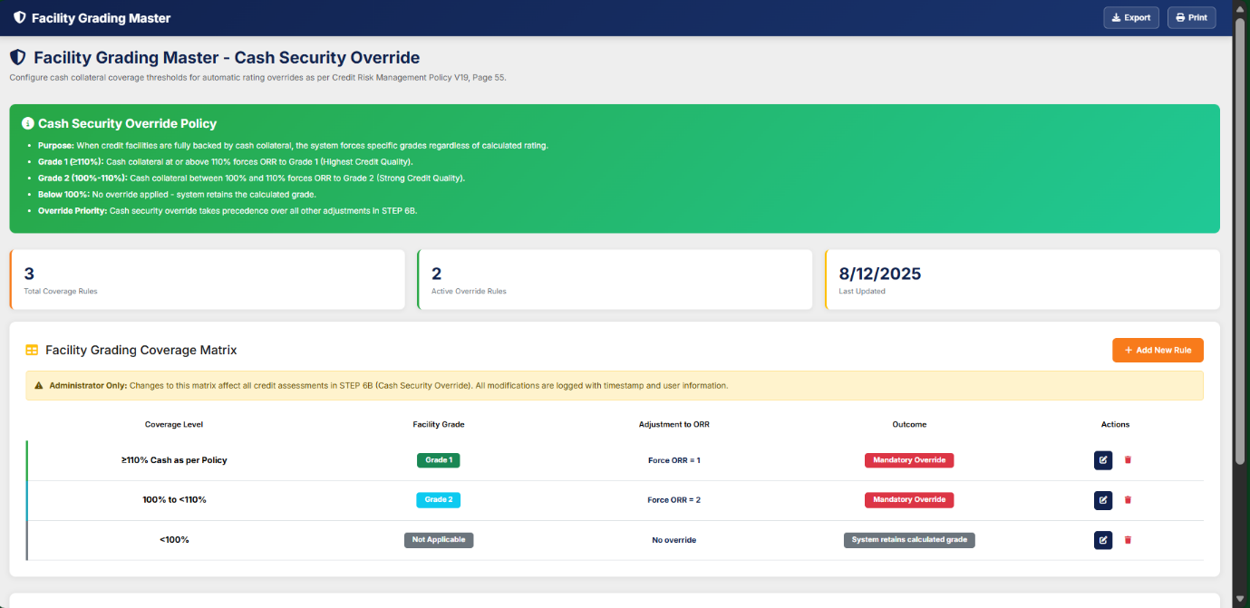
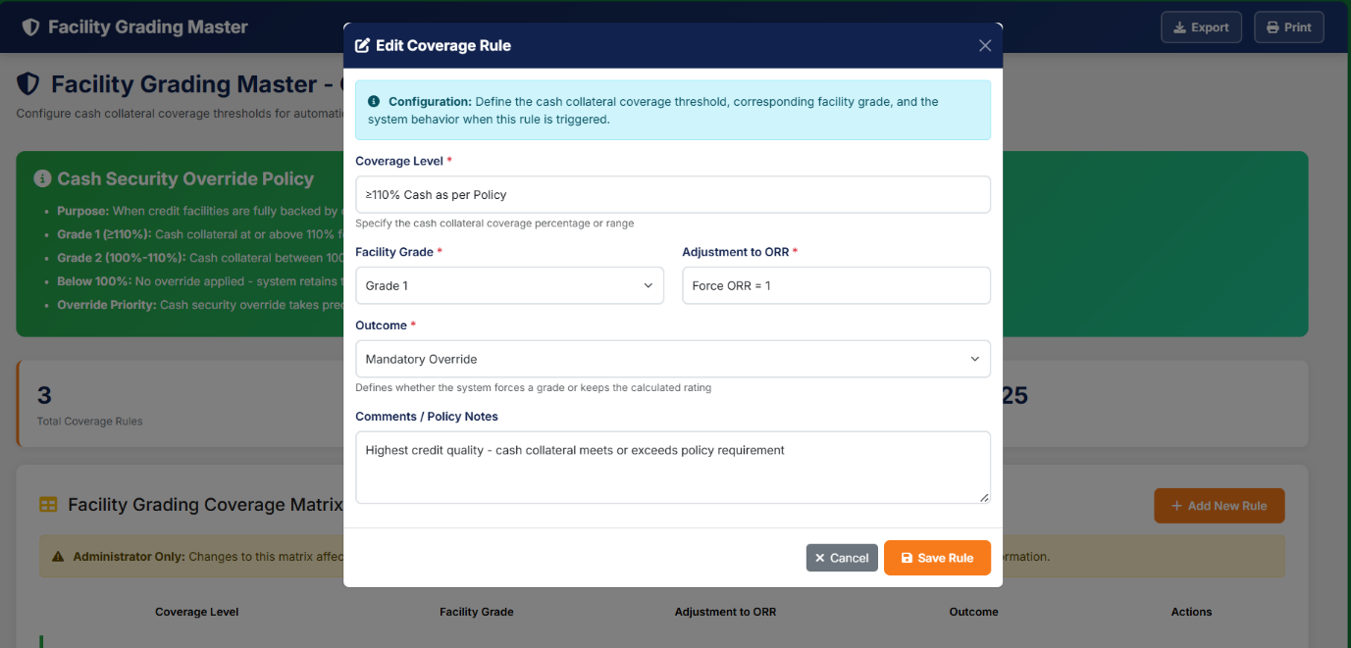
The Facility Grading Master - Cash Security Override screen enables authorized administrators to configure and maintain cash collateral coverage thresholds that trigger automatic rating overrides during credit assessment. This functionality implements the facility grading requirements outlined in the Credit Risk Management Policy V19, Page 55, Appendix 4, which assesses facility strength based on collateral and credit seniority for Loss Given Default (LGD) estimation.​
Business Purpose
When credit facilities are fully backed by cash collateral, the system enforces specific grades regardless of the calculated rating to reflect the extremely low severity of potential loss. This override mechanism ensures that facilities with sufficient cash coverage receive appropriate risk grades aligned with regulatory and policy requirements.​
Functional Requirements
Coverage Thresholds and Override Logic
The screen manages a coverage matrix with the following automated grade assignments:​
- Grade 1 (≥110% coverage): Cash collateral at or above 110% of the facility limit forces the Obligor Risk Rating (ORR) to Grade 1 (Highest Credit Quality/Extremely Low severity)
- Grade 2 (100%-110% coverage): Cash collateral between 100% and 110% forces ORR to Grade 2 (Strong Credit Quality/Very Low severity)
- Below 100% coverage: No override applied; the system retains the originally calculated grade
Coverage Matrix Administration
The screen displays a Facility Grading Coverage Matrix table showing:​
Column | Description
Coverage Level | Cash collateral percentage range (e.g., ≥110%, 100%-110%)
Facility Grade | Assigned grade (1-7) based on coverage
Adjustment to ORR | Override action ("Change ORR to 1" or "Change ORR to 2")
Outcome | Descriptive result of the override
Actions | Administrative functions (Edit/Delete)
The screen displays summary metrics including Total Coverage Rules, Active Override Rules, and Last Updated timestamp.​
Integration Points
Credit Assessment Workflow Integration
This configuration is implemented in STEP 6B: Facility Grading Override of the credit assessment workflow. The override applies only when:​
- User selects "Cash Security = YES" in STEP 1 (Entity Details)
- The system automatically calculates coverage as: (Cash Collateral Amount ÷ Total Credit Limit) × 100
- The entity is not classified as Non-Performing (NP), which are excluded from override eligibility
Override Precedence
Cash security override takes final precedence over all mandatory and discretionary adjustments in the rating calculation process.​
Access Control and Audit
The screen is Administrator Only, as changes affect all credit assessments system-wide. All modifications to the coverage matrix are logged with timestamp and user information to maintain a complete audit trail.​

External Rating Mapping & PD Management
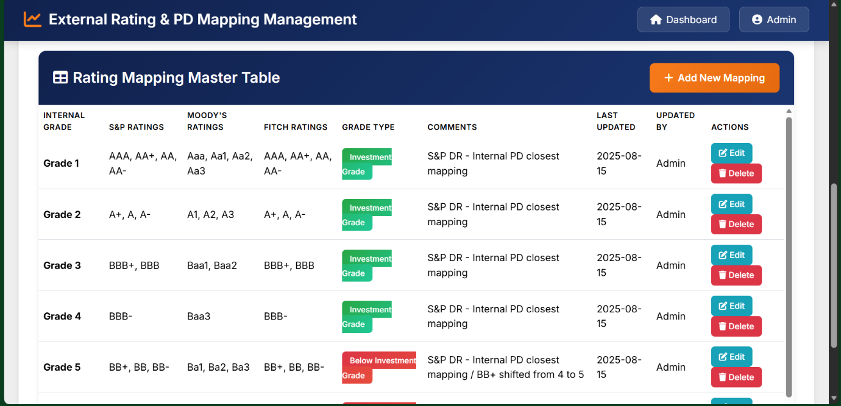
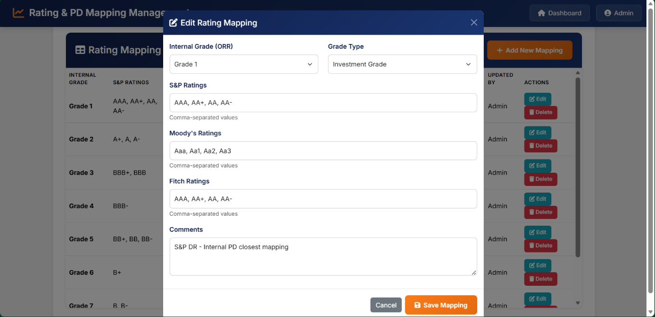
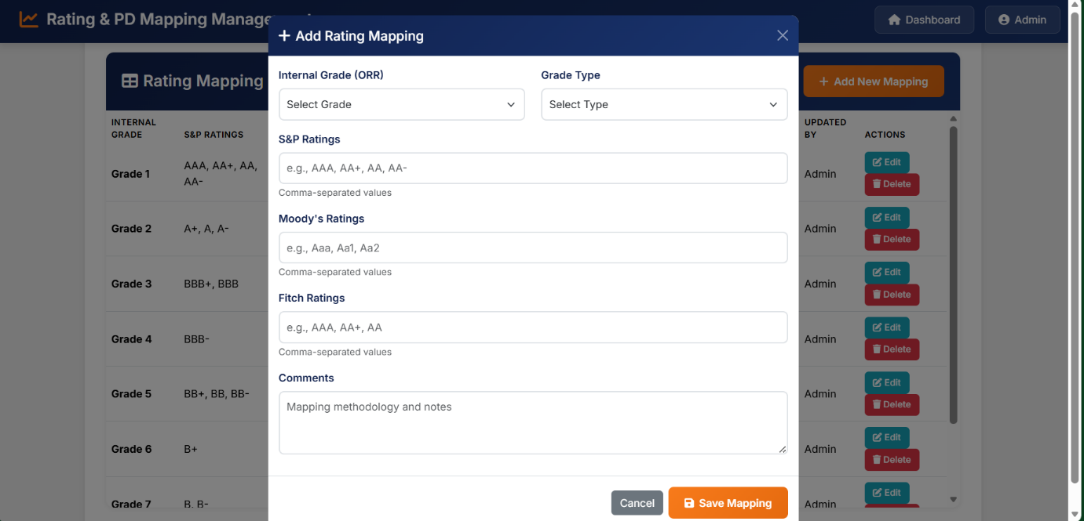
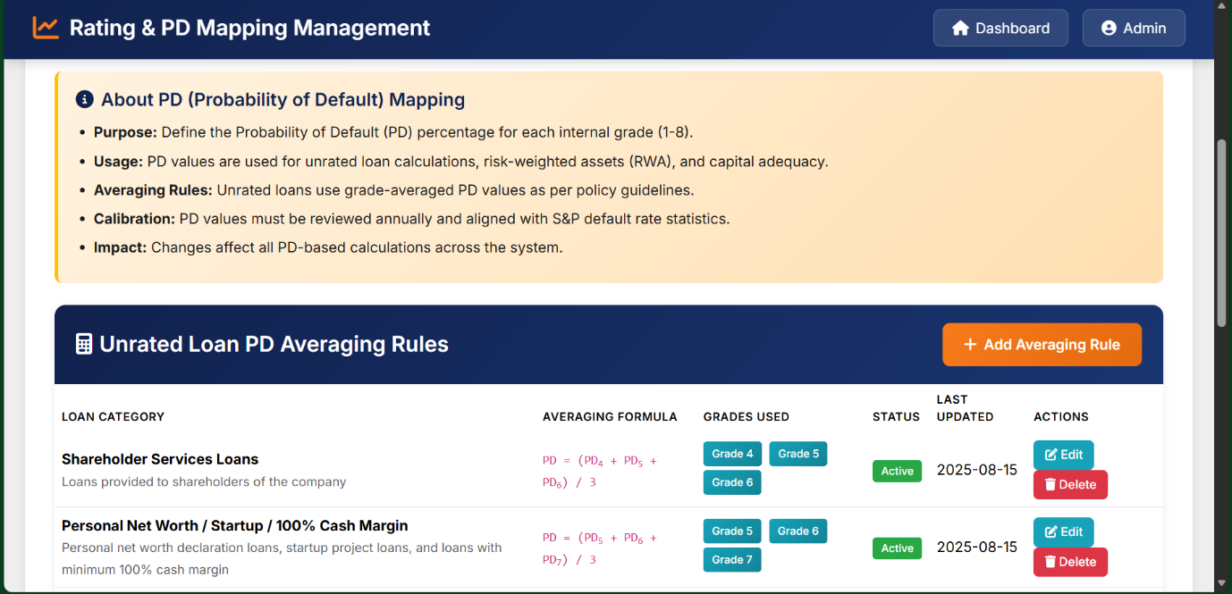
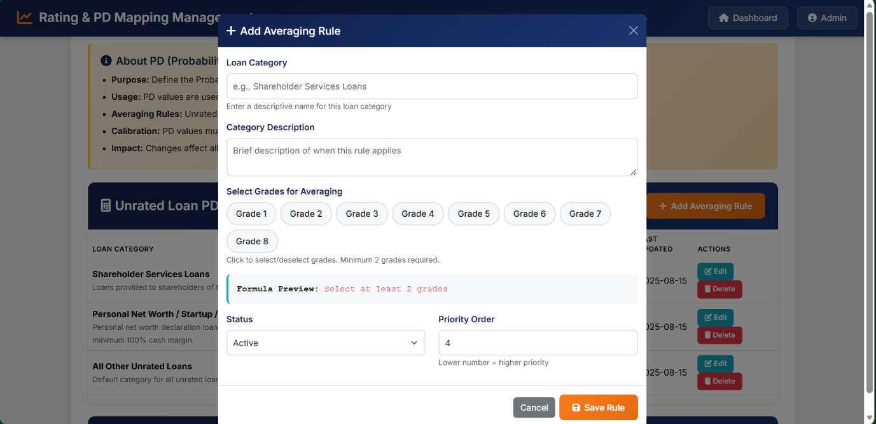
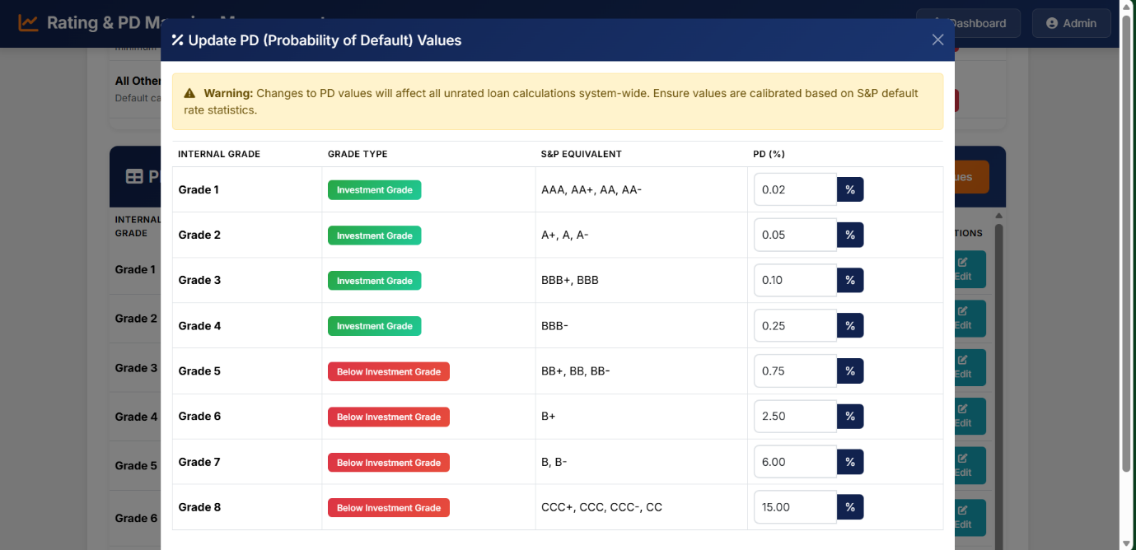

Overview
The External Rating Mapping Management screen enables authorized administrators to configure and maintain mappings between external credit agency ratings (S&P, Moody's, Fitch) and the organization's internal Obligor Risk Rating (ORR) grades. This master configuration ensures consistent translation of external credit assessments into the internal 8-grade rating scale used throughout the credit risk management framework.​
Business Purpose
The mapping functionality converts external agency ratings into internal ORR grades (1-8) based on Probability of Default (PD) alignment as defined in the Credit Risk Management Policy V19, Page 79. This standardization enables the organization to leverage external credit assessments from recognized rating agencies while maintaining consistency with internal risk classification and capital allocation requirements.​
Functional Requirements
Rating Grade Classification
The system categorizes internal grades into two risk tiers:​
- Investment Grade (Grades 1-4): Represents lower credit risk with higher quality obligors
- Below Investment Grade (Grades 5-8): Represents speculative or high-risk ratings with elevated default probability
Rating Mapping Master Table
The screen displays a comprehensive Rating Mapping Master Table with the following structure:​
Column | Description
Internal Grade | Internal ORR grade (1-8)
S&P Ratings | Mapped Standard & Poor's ratings for the grade
Moody's Ratings | Mapped Moody's ratings equivalent to S&P
Fitch Ratings | Mapped Fitch ratings equivalent to S&P
Grade Type | Classification (Investment Grade / Below Investment Grade)
Comments | Rationale and mapping methodology notes
Last Updated | Timestamp of last modification
Updated By | User who performed the last update
Actions | Administrative functions (Edit/Delete)
Standard Mapping Configuration
Based on S&P default rate analysis and PD closest mapping methodology, the standard configuration includes:​
- Grade 1: AAA, AA+, AA, AA- (Investment Grade)
- Grade 2: A+, A, A- (Investment Grade)
- Grade 3: BBB+, BBB (Investment Grade)
- Grade 4: BBB- (Investment Grade)
- Grade 5: BB+, BB, BB- (Below Investment Grade)
- Grade 6: B+ (Below Investment Grade)
- Grade 7: B, B- (Below Investment Grade)
- Grade 8: CCC+, CCC, CCC-, CC (Below Investment Grade)
Integration Points
Credit Assessment Workflow
External rating mappings are utilized when borrowers have published ratings from S&P, Moody's, or Fitch. The system automatically converts the external rating to the corresponding internal ORR grade during credit assessment processing
Default Probability (PD) Assignment
For unrated entities, the mapping table supports PD calculation through grade averaging:​
- Shareholder services loans: Average PD of grades 4, 5, and 6
- Personal net worth declaration loans, startup projects, 100% cash margin loans: Average PD of grades 5, 6, and 7
- All other unrated loans: Average PD of grades 6, 7, and 8

4.5. Credit Assessment

The Credit Assessment Module follows a structured, seven-stage stepper workflow designed to ensure completeness, transparency, and auditability across Business, Risk, and Approval units. Each step captures specific information, validates mandatory fields, and locks previously completed stages to maintain process integrity. The workflow supports both CIF-based and non-CIF customers and integrates automated rules such as financial ratio computation, rating model selection, and NP (Non-Performing) customer restrictions.

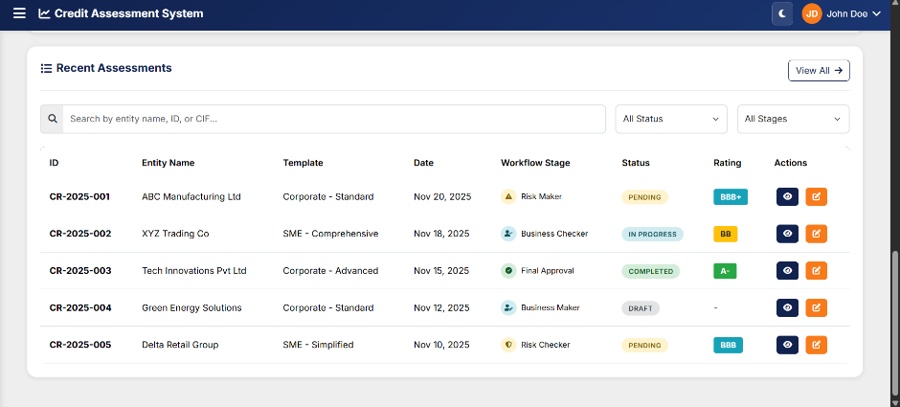

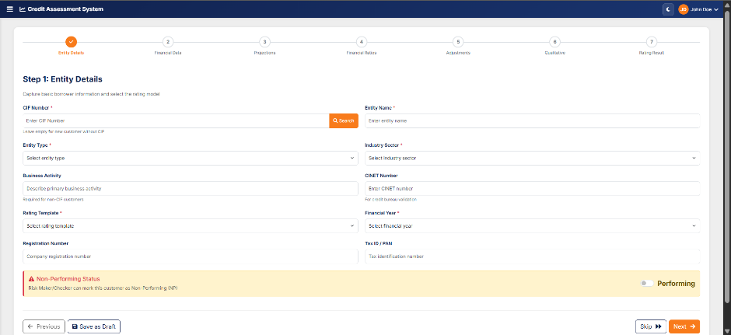
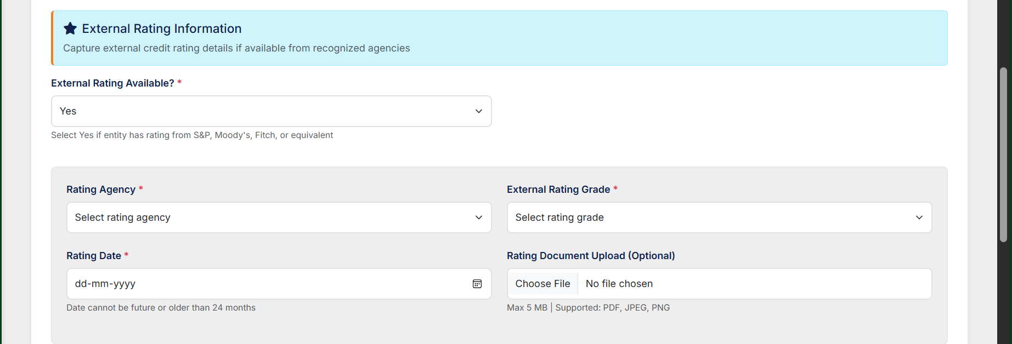
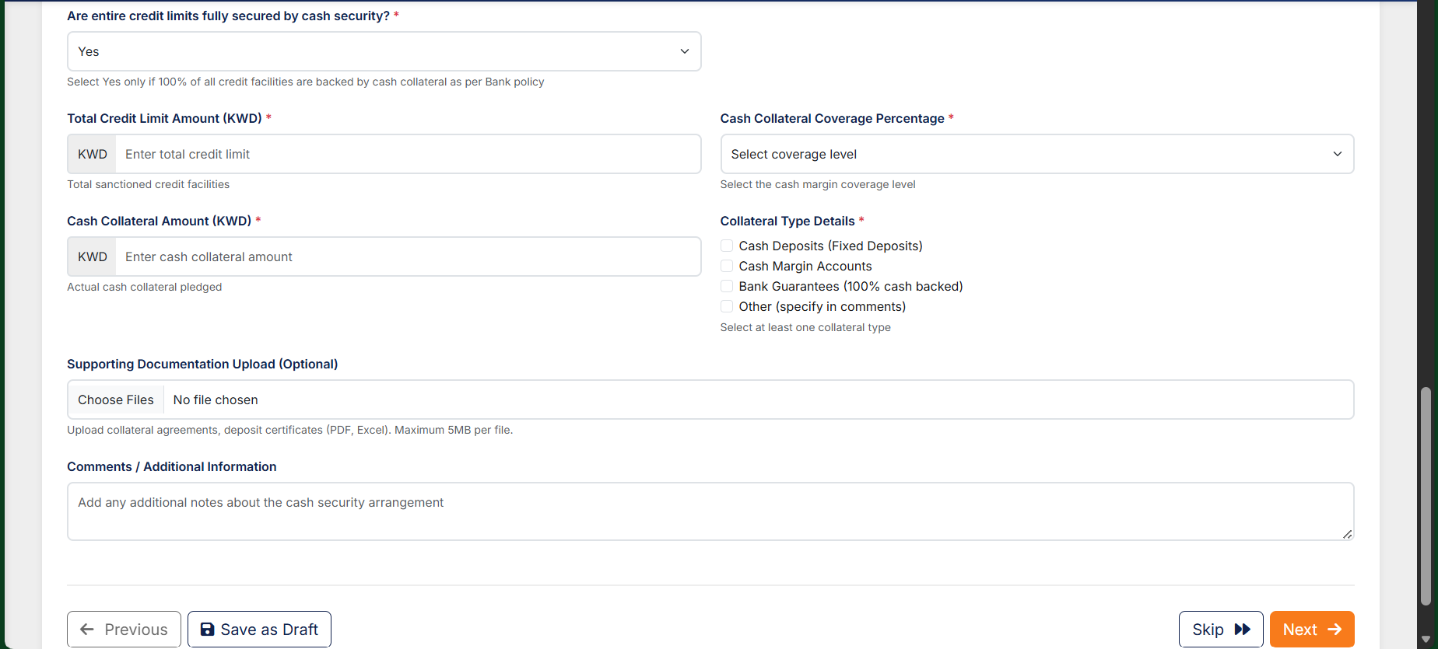
STEP 1 — ENTITY DETAILS
(Incorporating External Rating Section, Facility Security Section & Mapping Logic)
Step 1 captures all foundational and regulatory information required to initiate a credit assessment. The system validates entity existence, onboarding readiness, applicable templates, and mandatory policy-driven decision fields. Completion of Step 1 locks structural data and enables financial inputs.
1. CIF Search & Entity Auto-Population
- When a valid CIF number is entered:
  - System fetches historical entity information and past credit assessment data.
  - Retrieved values include demographics, regulatory identifiers, and prior ratings.
  - Historical data is displayed in an information banner for comparison.
If no historical data is found, fields remain editable and the user continues manually.
2. Mandatory Entity & Regulatory Details
Users must complete:
- Entity Type
- Industry Sector
- CINET
- Tax Registration ID
- Registration Number
- Business Activity Classification
Entity Type and Industry Sector selections drive downstream template availability.
3. Rating Template Selection
User selects the applicable rating model template (e.g., Trading & Manufacturing, Contracting & Services, etc.).
Once Step 1 is completed:
- Template becomes locked.
- Rating calculation framework for the next Step gets initialised.
4. NP (Non-Performing) Status Controls
- Risk Maker/Checker can mark an entity as NP.
- When NP = Yes:
  - System auto-assigns Internal Rating 9 / 10 / 11 based on classification rules.
  - The customer is marked FROZEN.
  - Rating templates for quantitative/qualitative assessment are disabled.
  - Reason for NP flagging is mandatory.
- When NP is cleared by Checker, the system re-enables templates.

5. External Rating Information (NEW – Mandatory Decision Section)
Mandatory Primary Field
External Rating Available? (Yes/No)
- Default: No
- Mandatory: Yes
When “Yes” is selected, the following conditional mandatory fields appear.
5.1 Rating Agency (Dropdown – Mandatory)
- S&P
- Moody’s
- Fitch Ratings
- Equivalent approved agencies
5.2 External Rating Grade (Dropdown – Mandatory)
Grades sourced from the client’s External Rating Master:
AAA, AA+, AA, AA-, A+, A, A-, BBB+, BBB, BBB-, BB+, BB, BB-, B+, B, B-,
CCC+, CCC, CCC-, CC, C.
5.3 Rating Date (Mandatory)
- Cannot be a future date
- Must be ≤ 24 months old
If date exceeds 24 months → system displays warning.
5.4 Rating Document Upload (Optional)
- Allowed: PDF, JPEG, PNG
- Max size: 5 MB
5.5 External Rating Mapping Logic (Internal Grade Assignment)
Using the client’s S&P Mapping Table:
(Direct extract from Credit Risk Management Policy)
4 Mapping of External Rating to…
External Grade Group | Internal ORR
AAA, AA+, AA, A | ORR 1
A+, A, A− | ORR 2
BBB+, BBB | ORR 3
BBB− | ORR 4
BB+, BB, BB− | ORR 5
B+ | ORR 6
B, B− | ORR 7
CCC+, CCC, CC, C | ORR 8

System Behaviour
- Once the External Grade is selected, the system auto-maps to the corresponding Internal ORR.
- If the user chooses not to use the external rating in the final determination:
  - System displays a warning message:
“External rating available but not applied. Please justify.”
Warning justification becomes a mandatory text field.
6. Facility Security Information (NEW – Mandatory Decision Section)
(Appears immediately after External Rating Information section)
Primary Field:
Are entire credit limits fully secured by cash security? (Yes/No)
- Default: No
- Mandatory
- Help text:
“Select Yes only if 100% of all credit facilities are backed by cash collateral as per Bank policy.”
When “Yes” is selected, the following conditional fields appear.
6.1 Total Credit Limit Amount (KWD – Mandatory)
- Numeric
- Must be > 0
6.2 Cash Collateral Coverage Percentage (Mandatory)
Dropdown options:
- ≥110% (Cash as per Policy)
- 100% to <110% (Cash at 100% of Facility)
- <100% (Partial cash security – Not eligible for override)
Help text explains the selection criteria.
6.3 Cash Collateral Amount (KWD – Mandatory)
- Auto-calculated = Total Limit × Coverage% (editable per design rules)
- Validated against Total Limit.
6.4 Collateral Type (Mandatory Multi-Select)
Options:
- Cash Deposits / Fixed Deposits
- Cash Margin Accounts
- 100% Cash-backed Bank Guarantees
- Other (with free text field)
6.5 Supporting Documentation Upload (Optional)
- PDF or Excel
- Multiple files allowed
6.6 Cash Security Validation Logic
- If Coverage <100% AND Cash Security = Yes
→ System throws error:
“Cash security override requires minimum 100% coverage. Please review or select ‘No’.”
- If Collateral Amount < Total Limit
→ Coverage cannot be marked as 100% or ≥110%.
- If user changes Cash Security from Yes → No after data entry
→ Confirmation dialog:
“Cash security override will be removed. Continue?”
7. Completion Rules for Step 1
Step 1 can only be submitted if:
- All mandatory entity fields are completed.
- External Rating conditional mandatory fields are validated when applicable.
- Cash Security conditional fields are validated when applicable.
Upon submission:
- Financial Input Section (Step 2) becomes active.

Client Additions –
- Auto-Fetch Customer Information via CIF
  - When CIF is entered, system must auto-fetch:
    - Entity Type
    - Industry Sector
  - Loaded data must appear pre-filled and editable.
- Business Activity Field
  - Add a new field Business Activity to support customers without CIF.
- CINET / Ci-Net Number
  - Add input field: CINET Number
  - Used for:
    - Validation of assessment
    - Future EOD file ingestion for bureau data
- Historical Auto-Population of Existing Customer Data
  - For returning customers, system must auto-load all previously captured:
    - Entity information
    - Financial statements
    - Qualitative answers
    - Past rating results
  - Pre-filled values must remain editable.

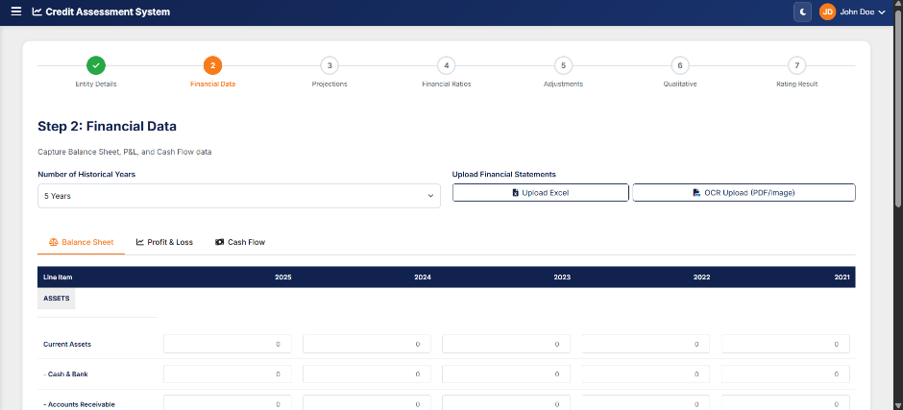
Step 2 – Financial Data
This step captures raw financial statements across multiple historical periods (3, 5, 10, 15, 20, 30 years).
Features include:
- Excel Upload and OCR PDF/Image Upload for automated ingestion of Balance Sheet, P&L, and Cash Flow data.
- Dedicated tabs for:
  - Balance Sheet
  - Profit & Loss Statement
  - Cash Flow Statement
- Auto-calculated subtotals such as Current Assets, Gross Profit, etc.
- Inline data entry cells with validation.
- Financial year columns adjust dynamically based on year selection in Step 1.
Once saved, financial data becomes the system’s base for projections and ratio computations.

Client Additions –
Support Full Financial Statement Structure
- UI must support complete statements:
  - Balance Sheet
  - Income Statement
  - Cash Flow
  - Financial Ratios
  - Projections Sheet
Alignment With Bank’s Excel Template
- All rows/columns must match the bank’s format exactly.
Excel Upload / OCR Extraction Enhancements
- Excel/OCR must:
  - Identify year columns
  - Identify financial line items
  - Auto-fill values year-wise
  - Allow manual correction
Dynamic Financial Years
- Replace fixed 5-year view with dynamic year selector (1–30 years).
- UI must expand/shrink columns accordingly.

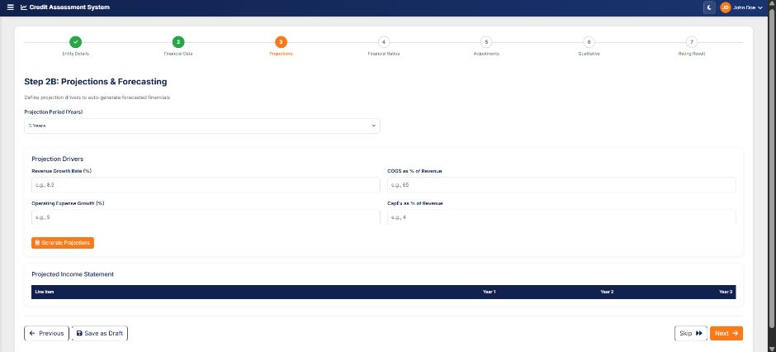
Step 3 – Projection & Forecasting
This stage enables forward-looking estimations required for rating models.
- Users enter projected figures for revenue, margins, cash flows, and key assets/liabilities.
- System may auto-suggest values based on historical trends.
- Projections are used to validate sustainability, capacity, and future PD (Probability of Default) curves.
Client Additions –
NEW SUBSECTION: STEP 2B – PROJECTIONS MODULE
Insert after Step 2 or create a new Step 2B.
4.5.x Projections & Forecasting
- Projection Input Screen
  - Capture projection drivers:
    - Revenue growth %
    - Operating expense %
    - Other configurable drivers
- Auto-Generated Forecast Statements
  - System must auto-generate:
    - Projected Balance Sheet
    - Projected Income Statement
    - Projected Cash Flow (if required)
- Integration With Scoring
  - Projections must influence:
    - Credit Score
    - Derived ratios
    - Final rating
- Bank-Configurable Projection Rules
  - Growth rules & mapping must be fully configurable per bank.
- Projections & Forecasting
- Projection Input Screen
- Auto-Generated Forecast Statements
- Bank-Configurable Projection Rules
- Historical Qualitative Data Retention

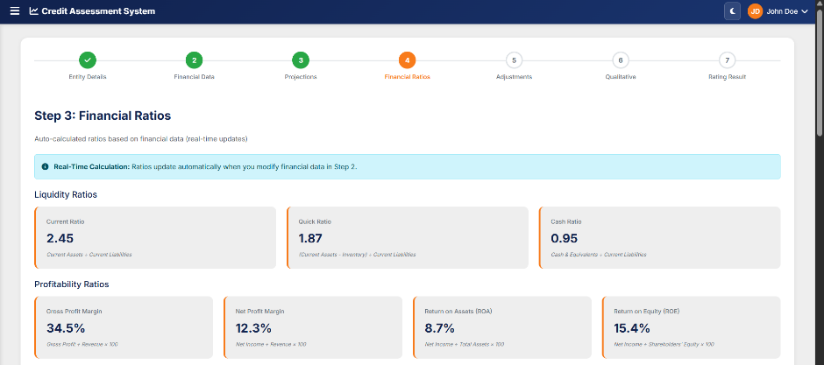
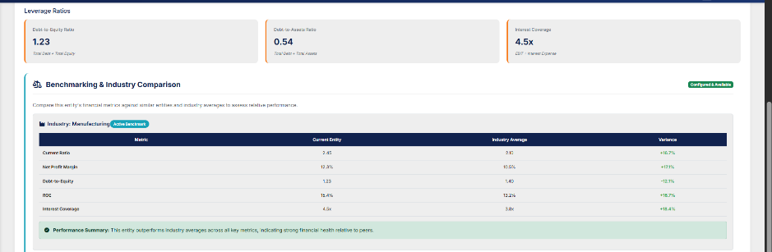
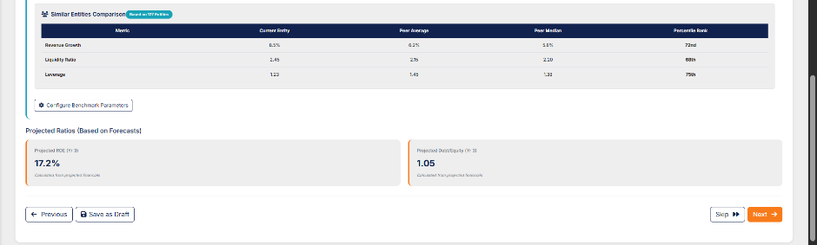
STEP 4: Financial Ratio Computations
Using inputs from Steps 2 & 3, the system automatically computes critical ratios, including but not limited to:
- Liquidity Ratios (Current Ratio, Quick Ratio)
- Leverage Ratios (Debt/Equity, Debt/EBITDA)
- Profitability Ratios (PAT Margin, ROE, ROA)
- Coverage Ratios (Interest Coverage)
The interface displays ratios in dedicated cards that highlight:
- Value
- Formula
- Trends
- Flags for red/amber thresholds
These ratios form the quantitative backbone of the rating model.

Client Additions –
Dynamic Ratio Calculation
- Ratios must auto-compute based on:
  - Imported data
  - Edited data
  - Projected financials
Real-Time Updates
- Editing any financial input must instantly update ratios.
Client Additions –
Historical Comparison
- User must be able to:
  - Open previous rating results in popup
  - Compare current vs previous ratings side-by-side

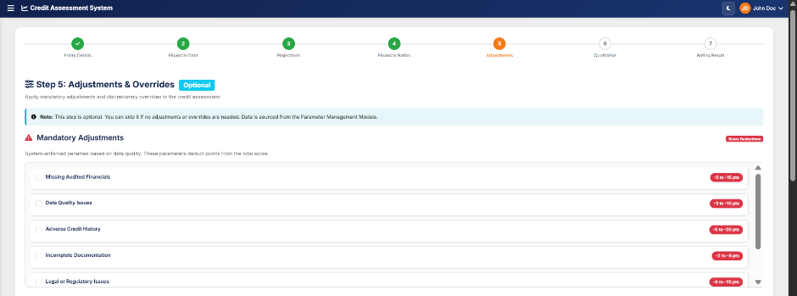
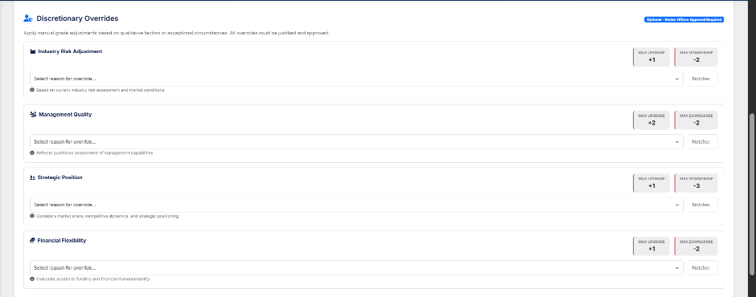
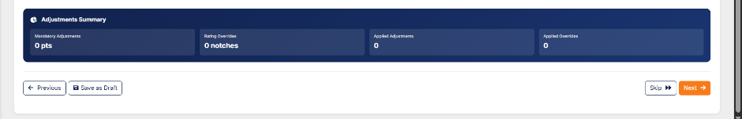
STEP 5: Adjustments
This step allows controlled adjustments subject to maker-checker workflows.
- Bank-defined adjustment modules (e.g., extraordinary income, one-off expenses).
- Each adjustment displays:
  - Description
  - Deduction Percentage or Value
  - Selection Checkboxes
- Selecting an adjustment recalculates the score instantly.
- System enforces adjustment limits (maximum upgrade/downgrade allowed per regulatory policy).
All adjustments are audit-logged with user, timestamp, and reason.
NEW SUBSECTION: MANUAL ADJUSTMENT LAYER
Insert after Rating Result or before Final Submission.
Manual Adjustment Layer
- Only accessible to authorized users (Senior Credit Officer, etc.).
- User can override computed score.
- System must capture:
  - Adjusted value
  - Reason for adjustment
  - User
  - Timestamp
- All overrides must be included in Audit Trail.
NEW SUBSECTION: DECISION SNAPSHOT
Insert after Manual Adjustment.
Decision Snapshot
At final submission, store a complete snapshot including:
- All financial inputs
- All ratios
- All projections
- All qualitative scores
- Scoring parameters used
- Adjustment logs

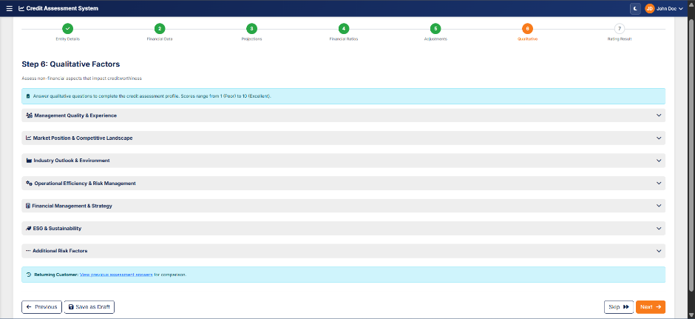

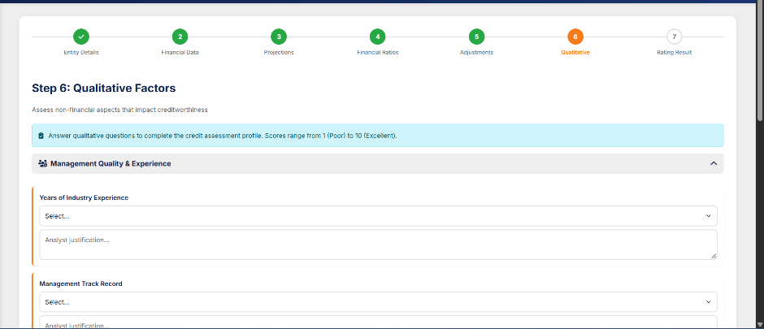
STEP 6: Qualitative Assessment
This section captures non-financial factors that influence borrower creditworthiness.
- Each category (Management, Governance, Market Position, Operations, Reputation, etc.) is broken into granular questions.
- Questions support scoring using dropdowns or radio selections.
- Every question is designed with pre-defined scoring weights as per rating methodology.
- Qualitative score merges with quantitative score to compute final borrower grade.
Collapsible panels provide a clean UI for navigation and reduce cognitive load.
Client Additions –

Grouped Questions Support
- Questions must be organized in configurable groups.
Configurable Question Logic
- Admin must configure:
  - Questions
  - Groups
  - Scoring rules
  - Weightages
Miscellaneous Question Subsection
- Add a separate Miscellaneous Questions area before final score.
Historical Qualitative Data Retention
- System must retain qualitative answers across assessments and show history.

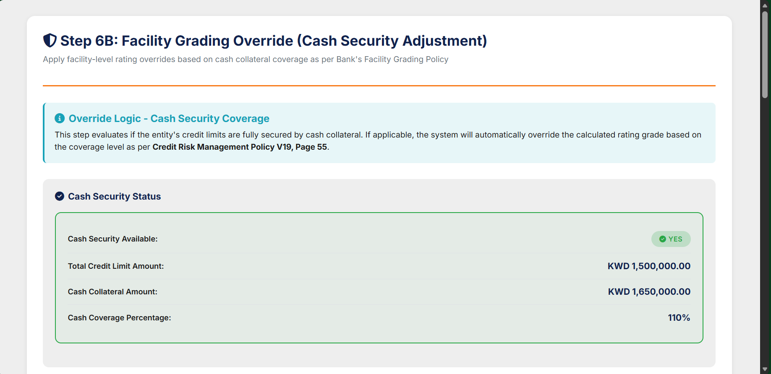
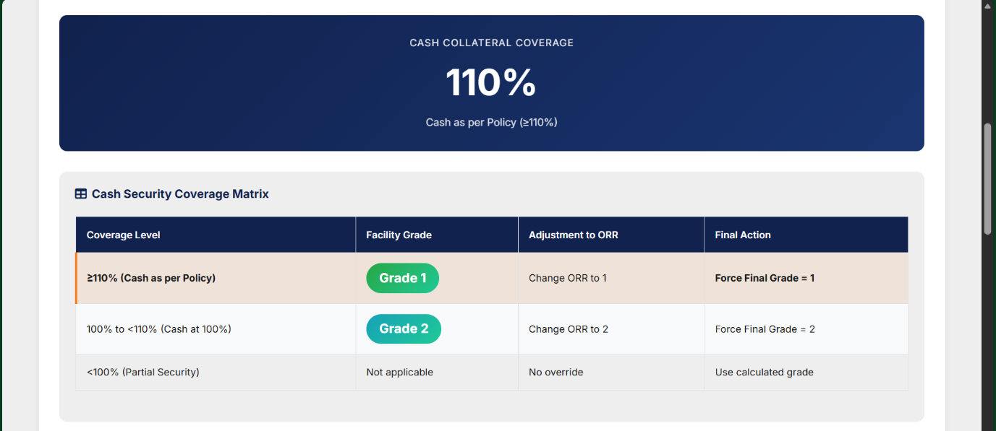
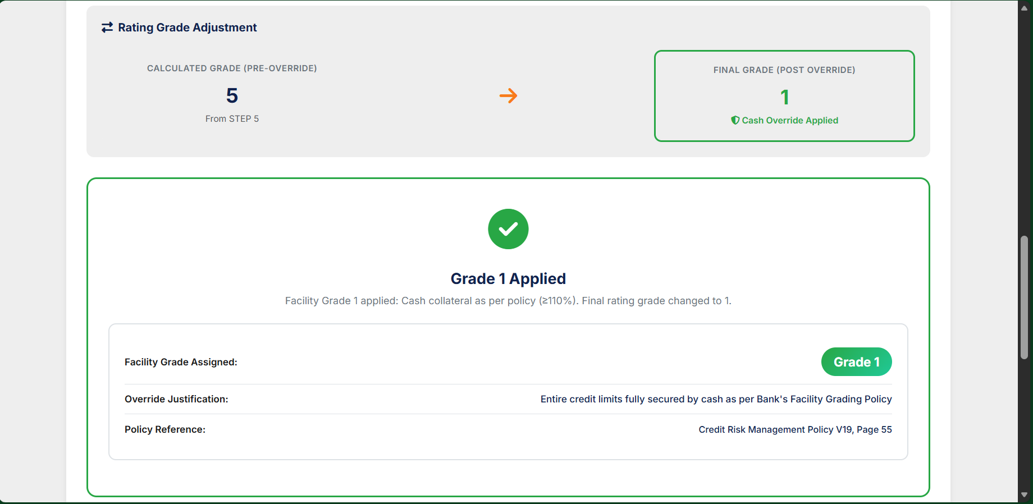

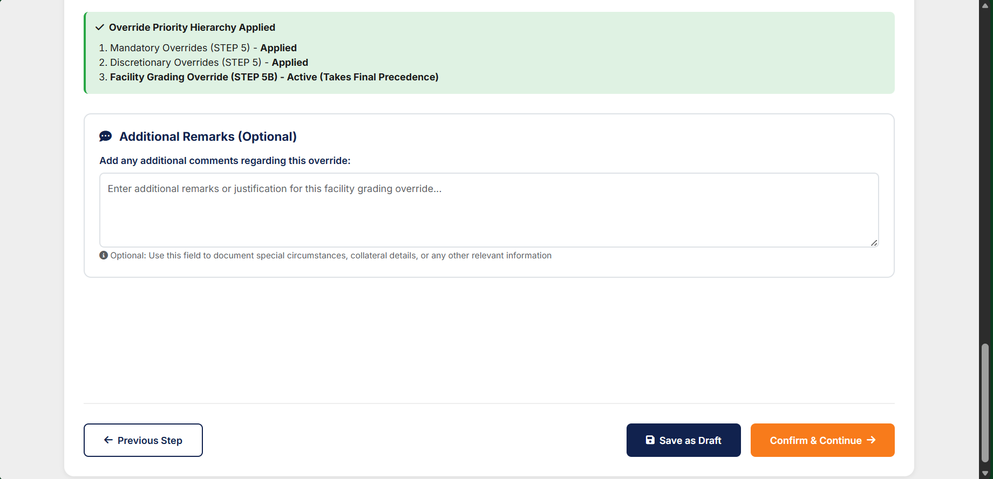
STEP 6B — FACILITY GRADING OVERRIDE (CASH SECURITY OVERRIDE)
Step 6B is triggered only when Step 1 indicates Cash Security = Yes.
The objective is to override the calculated internal rating based on the customer’s cash collateral strength,
1. Policy-Driven Facility Grades
Coverage Level | Facility Grade | Adjustment to ORR | Outcome
≥110% Cash as per Policy | Grade 1 | Force ORR = 1 | Mandatory Override
100% to <110% | Grade 2 | Force ORR = 2 | Mandatory Override
<100% | Not Applicable | No override | System retains calculated grade
This matrix is directly reflected in the Step 6B UI and system logic.
2. Pre-Override vs Post-Override Rating Logic
The system compares:
- Calculated Rating Grade (from Previous Steps)
- Override Grade (from Step 6B Cash Security Evaluation)
Override precedence:
- Financial Factors (Steps 2 & 4)
- Mandatory Overrides (Step 5)
- Discretionary Overrides (Step 5)
- Qualitative Factors (Step 6)
- Cash Security Override (Step 6B) – THIS TAKES FINAL PRIORITY

3. Conditions Where Step 5B Is NOT Applicable
- If entity is NP (Internal Rating 9/10/11)
Cash security override is blocked:
“Not applicable for NP borrowers; NP rating remains final.”
- If coverage <100%
→ Override not allowed.
- If Cash Security = No in Step 1
→ Step 5B is skipped entirely.

4. External Rating Interaction
If:
- External Rating exists, and
- Cash Security Override exists
→ Cash Security Override takes priority.
UI shows a combined warning indicating final grade selection.
Example, if External Rating = ORR 3 and Cash Security Override = Grade 1:
Final assigned grade = 1
(as per hierarchy)

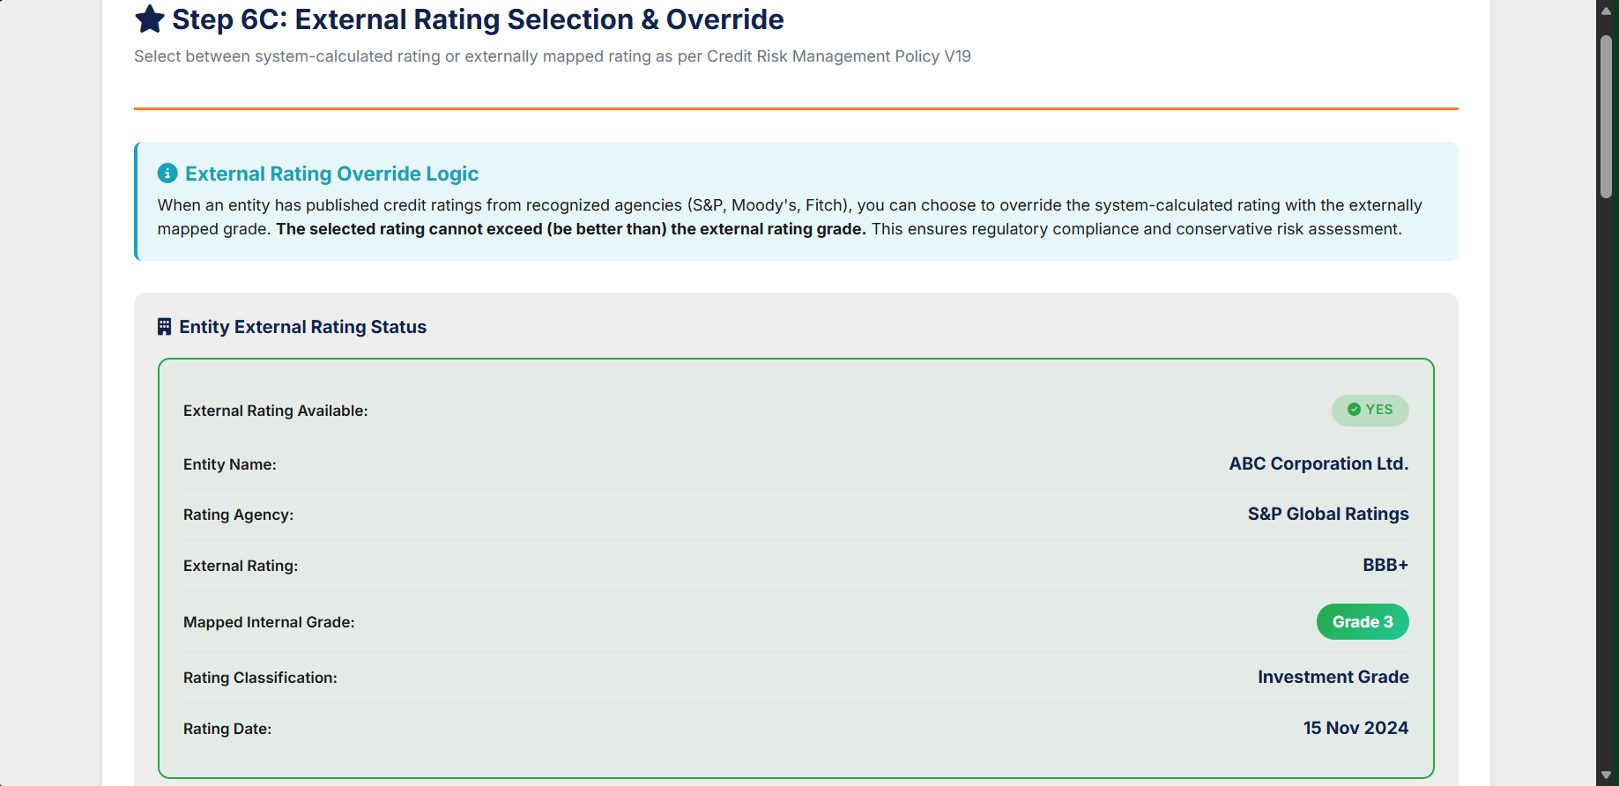
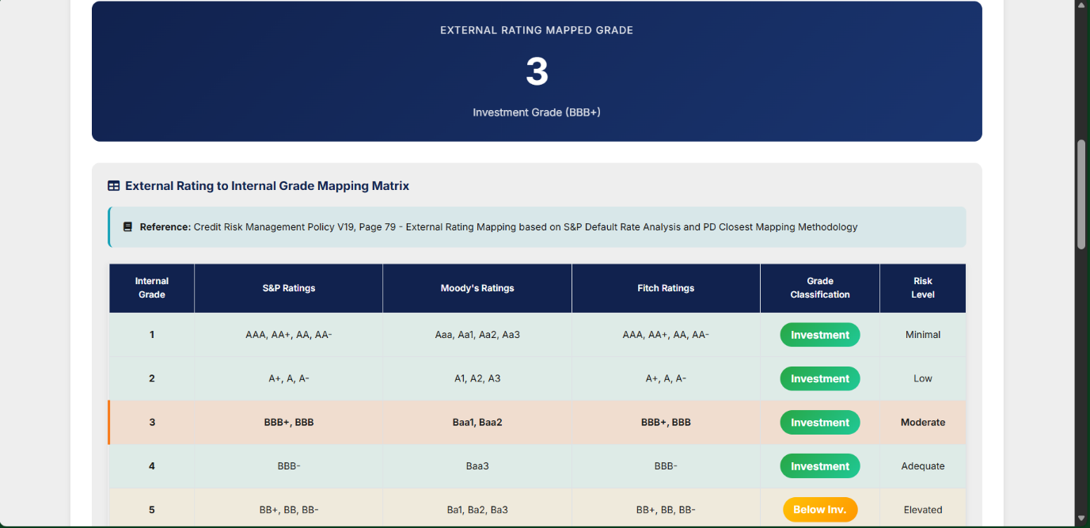
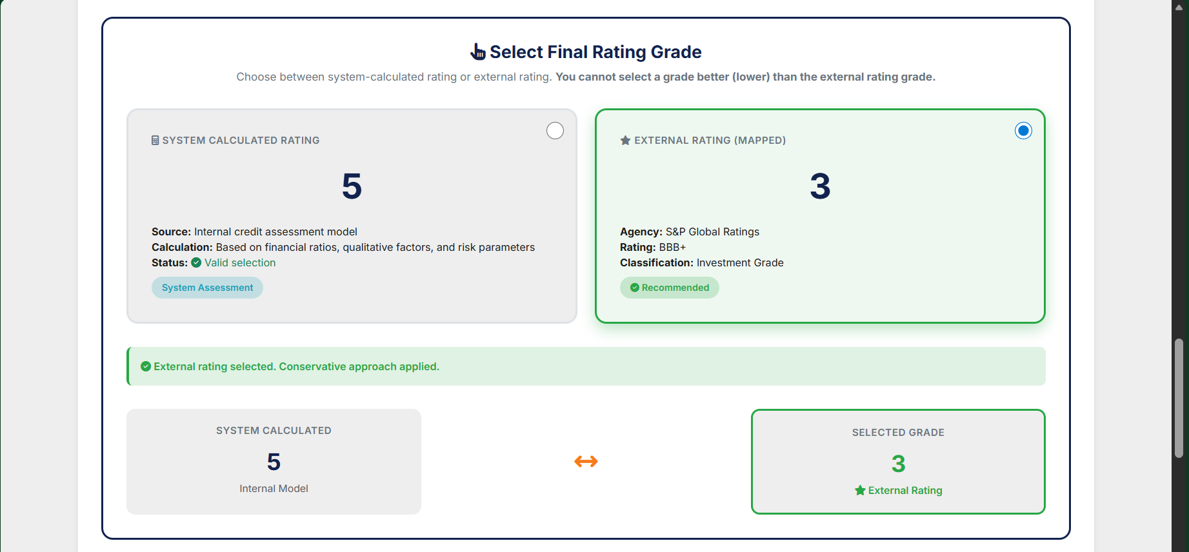

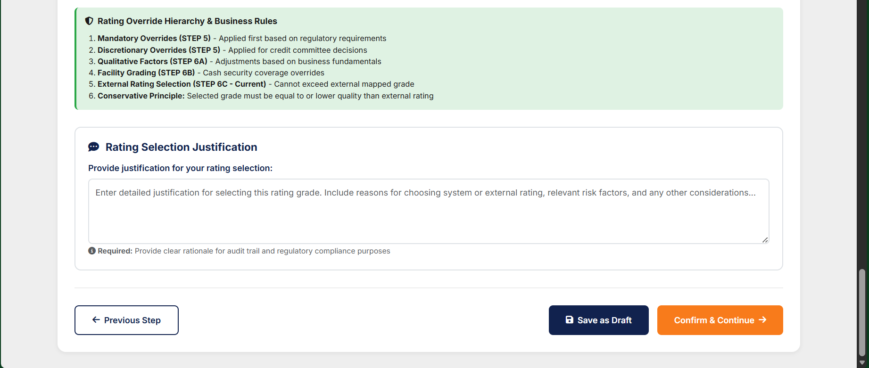
The External Rating Selection & Override screen (Step 6C) enables authorized credit assessment users to make the final rating determination when an entity possesses published credit ratings from recognized external agencies (S&P Global Ratings, Moody's Investor Service, or Fitch Ratings). This screen provides a decision interface where users can select between the internally calculated Obligor Risk Rating (ORR) grade or the externally mapped grade, subject to regulatory constraints and conservative credit risk principles.​
The screen serves as a critical control point in the credit rating workflow, ensuring that external credit assessments from internationally recognized rating agencies are appropriately considered while maintaining alignment with the organization's internal risk classification framework and Basel compliance requirements.​
Conservative Principle (Primary Constraint)
Statement: Selected internal grade CANNOT be better (numerically lower) than the externally mapped grade.
Examples:
- ✅ Valid: External Grade = 3, System Grade = 5, User can select either
- ✅ Valid: External Grade = 3, System Grade = 3, User can select either
- ❌ Invalid: External Grade = 5, System Grade = 3, User CANNOT select system grade
Rationale: Ensures conservative risk assessment; external ratings from recognized agencies provide floor for internal ratings to prevent over-optimistic assessments.

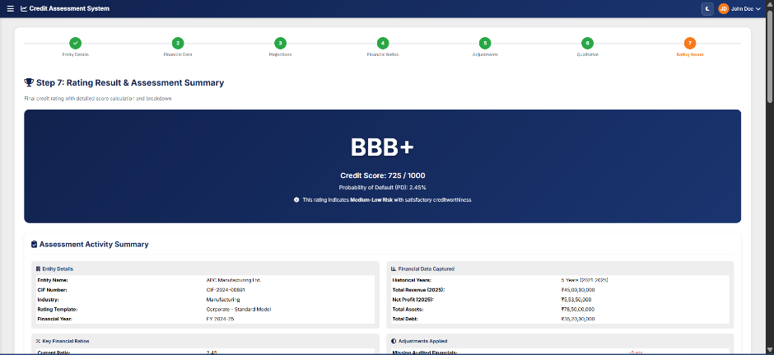

STEP 7: Rating Result
The final step consolidates all quantitative and qualitative scores.
Displayed elements include:
- Final Rating Grade (e.g., A, BBB+, BB)
- Score (Numeric)
- PD % Value
- Breakdown of Weightage Components
- Applied Adjustments Summary
- Qualitative & Quantitative Contribution Chart
For NP customers (Step 1 override), the system shows:
- Locked rating of 9 / 10 / 11
- Frozen customer badge
- Warning message indicating future templates remain frozen until status is changed
Final submission triggers the maker-checker workflow and records a complete audit trail.

Overall Workflow Behaviour
Aspect | Description
Linear Progression | User can move forward but cannot skip mandatory steps.
Maker-Checker Compliance | Each stage logged and submitted for review based on user role.
Auto-Validation | Mandatory fields and ratios validated automatically before progressing.
Template-Driven | Rating template selection determines weightages, qualitative sections, ratio mapping.
Frozen NP Behaviour | When NP flag is ON, rating calculation switches to NP rating logic and all templates are locked.
Auditability | Every action (data entry, adjustment, override, NP flag) is logged.

Client Additions
Rating Output Printing Requirement
The system shall provide the capability to generate and print the rating output for each borrower at both the Business Checker and Risk Checker stages.
This functionality must be available prior to the Final Risk Approver’s rating freeze action, enabling Business and Risk Checkers to review, validate, and retain rating outputs for assessment and verification purposes.
The printed rating output shall follow the format and layout as specified in Attachment 1 and must reflect the latest calculated rating at the time of printing.
Output – PDF or XLS
Attachment 1 is stated below as an illustration –
Obligor Risk Rating Output Document serves as the official, system-generated rating certificate for every completed borrower assessment, even before its freezing once the final score is generated. This document must follow the standardized structure provided by the client in Attachment 3 and must be generated consistently for all rating templates (Contracting, Trading, Investment, PNW, etc.).
Final Rating Master Table (CONTRACTING & SERVICE TEMPLATE)
Score Range | Grade
0 – 139 | 8
140 – 159 | 7
160 – 174 | 6
175 – 189 | 5
190 – 204 | 4
205 – 214 | 3
215 – 224 | 2
225 and above | 1

Final Rating Master Table (INVESTMENT REAL ESTATE & FINANCE TEMPLATE)
Score | Grades
0 | 8
140 | 7
160 | 6
175 | 5
190 | 4
205 | 3
215 | 2
225 | 1

Final Rating Master Table (PERSONAL NETWORTH DECLARATION BORROWERS GRADING TEMPLATE)
Score Greater than or equal to | Score Less than | PNWD GRADE | CORP GRADE
18.89 | 63.35 | 5 | 7
63.35 | 84.21 | 4 | 6
84.21 | 91.92 | 3 | 5
91.92 | 100.00 | 2 | 4
100.00 | 100.00 | 1 | 2

Final Rating Master Table (Trading & Manufacturing TEMPLATE)
Score | Grades
0 | 8
140 | 7
160 | 6
175 | 5
190 | 4
205 | 3
215 | 2
225 | 1

Note -
Final Rating Grades must be numerical (1–11) | Internal rating scale should use only numerical grades

Reference –

HIGH-LEVEL INTER-DEPARTMENT WORKFLOW

A. CBD / IBD WORKFLOW (Business Unit)
This unit performs the pre-risk business checks, consisting of:
1. Business Maker (X123)
- Creates the case
- Enters all customer/entity details
- Uploads documents
- Saves drafts or submits to checker
Transition → Submits the case to Business Checker

2. Business Checker (X123)
- Reviews data entered by Maker
- Can approve or return for corrections
- Cannot modify actual data (remarks only) “Business Checker can review and modify data points entered by the Business Maker before approving.”
Two possible paths:
- Return → Goes back to Business Maker for corrections
- Submit Forward → Sends case to Risk Verifier (RMD)
This transition to RMD triggers a system notification.

B. RISK MANAGEMENT DEPARTMENT (RMD) WORKFLOW
3. Risk Maker (X123)
- Reviews the case sent from CBD/IBD
- Risk Maker / Risk Checker can mark a customer as Non-Performing.
- When marked NP, the system automatically assigns a rating of 9, 10, or 11.
- All future rating templates for that CIF remain frozen until the status changes back to “Performing”.
- Fills Risk Parameters & qualitative risk details
- Uploads risk documents
- Can save draft
- Submits to Risk Checker
Transition → Risk Checker

4. Risk Checker (X123)
- Validates the risk assessment performed by the Risk Maker
- Risk Maker / Risk Checker can mark a customer as Non-Performing.
- When marked NP, the system automatically assigns a rating of 9, 10, or 11.
- All future rating templates for that CIF remain frozen until the status changes back to “Performing”.
- Adds remarks
- Approves or returns for risk-level rework: “Risk Checker is allowed to modify data points before approval.”
If approved:
Transition → Final Approver “Rating report generation will occur after the approval stage, as the approval process is already completed prior to report generation.”
5. Final Approver (X123)
- Performs final credit-level approval
- Confirms end-to-end completion from Business & Risk
- Once approved, the entire assessment becomes FROZEN
- No further edits allowed
End State → Assessment Frozen + Final Rating Report Enabled

(MESSAGE FLOWS)
1. Notification (CBD/IBD → RMD)
Triggered when Business Checker forwards the case to Risk Verifier:
- Risk team receives workflow notification
- Assessment enters Risk Draft state
2. Submission Flow (RMD → CBD/IBD for tracking)
Once Risk Approval completes, the submission progresses to Final Approver:
- Final approval notification
- System locks record post-approval

Risk Management Department (RMD) Workflow
- Risk Maker (X123)
  - Can edit data points entered by business users.
- Risk Checker (X123)
  - Can modify data points.
  - Option to return to Risk Maker.
- Final Approver (X123)
  - Can return the application to any Risk user for changes or make changes directly.

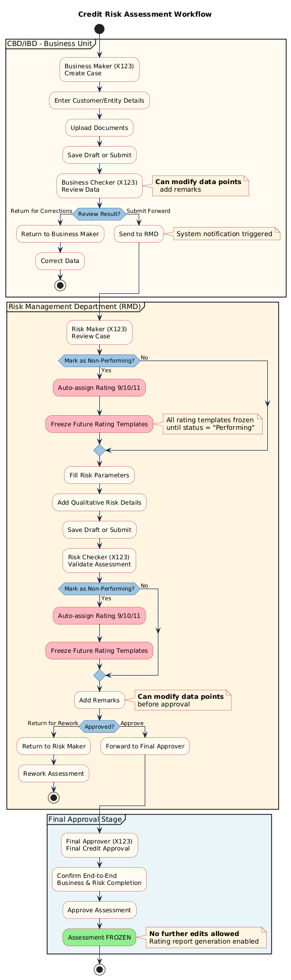

4.6. Reports
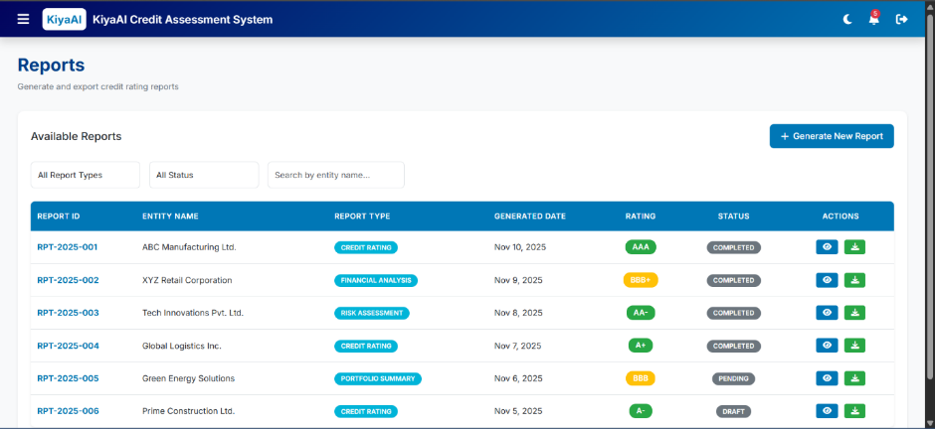

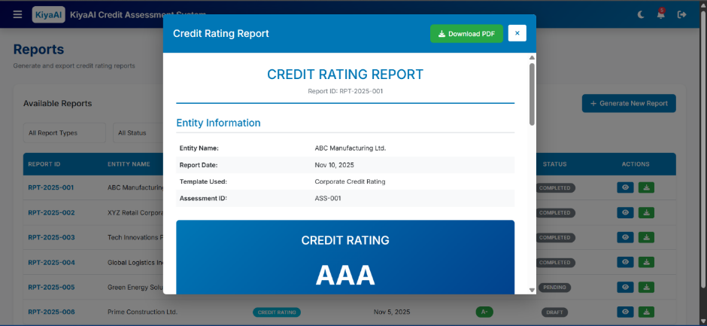
The Reports module allows users to generate, download, and review credit assessment reports.
It provides standardized document formats based on templates, offering transparency and auditability of rating results.
The Reports screen includes:
A. Report List Table
Columns:
- Report Name
- Description
- Report Type (PDF/Template-Based)
- Last Generated
- Actions (Generate, Download, View)
B. Report Generation Filters
For applicable reports:
- Date Range
- Status
- Template
- Entity Name
- Financial Year
These filters refine the dataset before generating output.
C. Output Format
Reports generated in:
- PDF
- Excel (if defined)
- System-defined Template Output
Types of Reports
Common reports include:
- Assessment Summary Report
- Parameter Score Report
- Final Rating Report
- Portfolio Overview Report
- Assessment Status Report

Report Generation Process
- User selects the report type.
- Applies filters based on available input parameters.
- System fetches relevant data set.
- Backend prepares the report using predefined template.
- User downloads or previews the output.

Report Template Management
- System supports configuration of:
  - Report Layout
  - Header/Footer
  - Branding
  - Section Arrangement
- Admin module controls available templates (future scope if not yet implemented).

Report –
Portfolio-Level Assessment Report
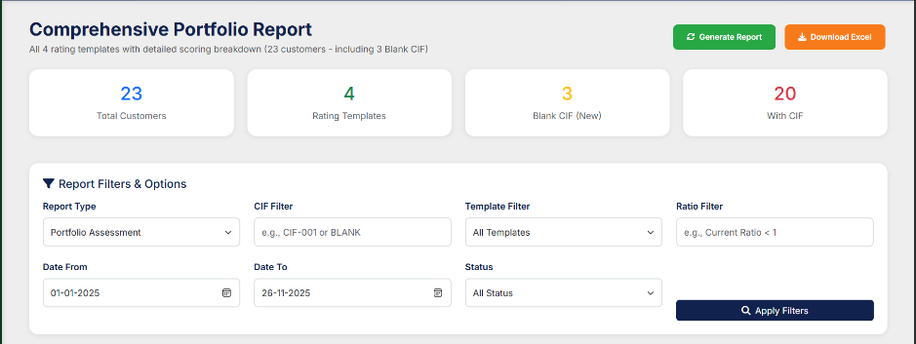

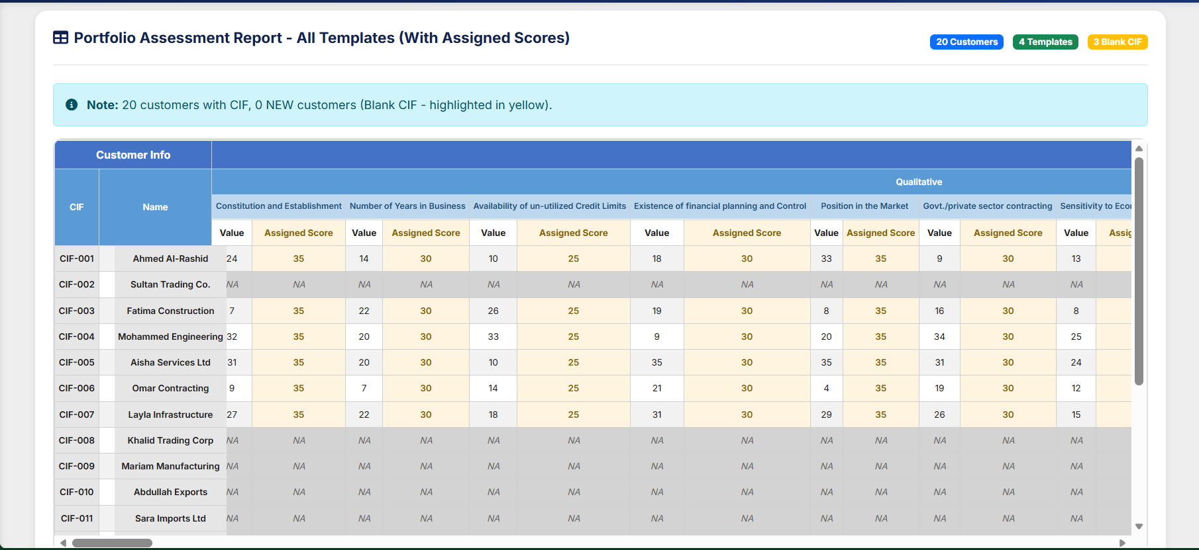

This report represents a Customer-Level Assessment under the Contracting and Services credit scoring model.
The Portfolio Assessment Report provides a consolidated view of all customer assessments across all templates. Each customer is evaluated based on multiple quantitative and qualitative parameters.
For every parameter, the report now shows two details:
- Value i.e. (Input Value) – The actual data or metric captured for the customer (e.g., number of years in business, credit limit availability, market position, etc.).
- Assigned Score – The score given based on the value, according to the defined scoring rules in the assessment template.
This combined view helps users understand both the customer Calculated Score information and the derived assessment score used for portfolio evaluation. It also highlights customers without CIF numbers in yellow for quick identification.
Note –
The first four columns of the report are fixed and must always appear in the following order:
Sr. No. | Column Name | Description
1 | Assessment Date | The date on which the rating assessment was performed.
2 | CIF Number | Unique Customer Identification File number.
3 | Borrower Name | Name of the applicant/borrower being assessed.
4 | Rating Template Type | Indicates whether the assessment used the Contracting / Trading / Investment / Personal Net Worth template.
These columns must remain static for all template types and appear before any parameter-level information.
For every financial, business/qualitative, and risk parameter configured in the selected rating template, the report will generate two columns per parameter:
- Input Value Column – The raw value or qualitative response entered during the assessment.
- Score Column – The numerical score assigned based on the scoring matrix.
The dual-column structure ensures full transparency between input data and scoring output.
• Only parameters applicable to the selected template must appear.
• Parameters not used in a particular template must display “NA” in both input and score columns.
Example –
 |  |  |  | Qualitative Parameters
 |  |  |  | Affiliates due to Net Worth |  | Current Ratio
Date | CIF | Name | Rating Template Type | Input Value | Score | Input Value | Score
12-11-2025 | 564738 | Abdullah Al-Mutairi | Contracting | 1.25 Cr | 18 | 1.45 | 22.5
12-11-2025 | 884512 | Fahad Al-Sabah | Trading | NA | NA | NA | NA
13-11-2025 | 776431 | Jassem Al-Bader | Contracting | 3.40 Cr | 25 | 1.88 | 30
14-11-2025 | 992341 | Lulwa Al-Harbi | Investment | NA | NA | NA | NA
15-11-2025 | 112563 | Shaikha Al-Otaibi | Personal Net Worth | NA | NA | NA | NA

After all parameter-level columns, the following rating computation columns must appear in the order defined below:
Sr. No. | Computation Column | Description
1 | Initial Score | Sum of all parameter scores before any adjustments.
2 | Initial Rating Grade | Numerical grade (1–11) derived from the Initial Score using the rating grade matrix.
3 | Mandatory Override – Input Details | Displays the trigger values (e.g., NPA flag, negative net worth) that resulted in a mandatory override.
4 | Mandatory Override – Adjusted Grade | Grade after applying mandatory override rules.
5 | Discretionary Override – Input Details | Displays the comments/reasons provided by the assessor for discretionary override.
6 | Final Grade | Final computed rating grade (1–11) after applying all overrides.

Historical Rating Report (Quarterly Rating Report)
The Historical Rating Report provides a quarterly view of customer evaluations, capturing rating changes over time. Customers are assessed every three months, and the most recent rating is automatically updated and displayed in the system for each evaluation cycle.
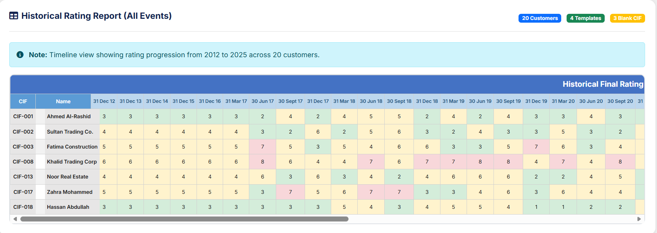
Note –
The Quarterly Rating History Report provides a chronological, quarter-by-quarter matrix view of historical borrower rating grades for regulatory reporting, portfolio monitoring, and rating migration analysis.
Fixed Columns (First Two Columns)
Column | Description
CIF Number | Unique borrower identification used as a row anchor.
Borrower Name | Name of the borrower associated with the CIF.
These columns remain constant for all report outputs.
Following the two fixed columns, the report must dynamically generate one column for each quarter-end date within the user-selected period.
Quarter column headers must be formatted using quarter-end dates (YYYY-MM-DD), for example:
- 2023-03-31
- 2023-06-30
- 2023-09-30
- 2023-12-31
If the user selects a time range from 2012 to 2025, the system must automatically generate all quarter-end dates from Q1 2012 through Q4 2025, resulting in a matrix potentially spanning dozens of columns.
Sample Table Format (Dummy Illustration)
CIF | Borrower Name | 2023-03-31 | 2023-06-30 | 2023-09-30 | 2023-12-31
778912 | Abdullah Al-Mutairi | 6 | 5 | 5 | 7
559034 | Fahad Al-Sabah | 4 | 4 | 3 | 3
992341 | Lulwa Al-Harbi | 7 | 7 | 6 | 6
112563 | Shaikha Al-Otaibi | 5 | 6 | 5 | 5

Historical Rating Comparison Report
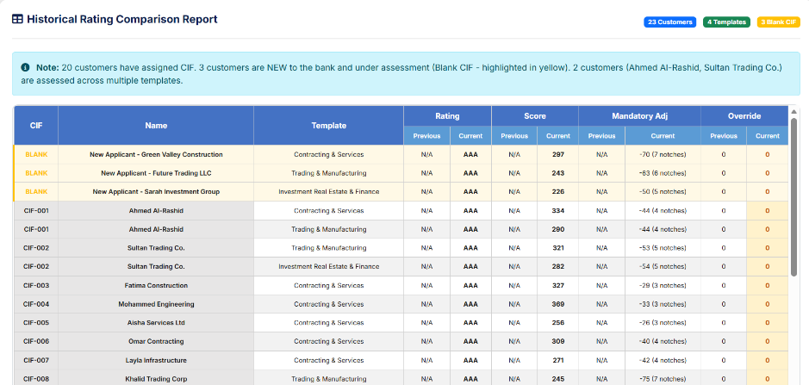
Blank CIF Report
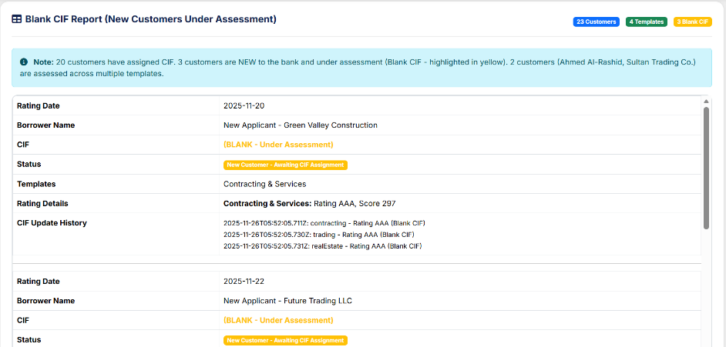

IFRS9 Latest Rating Report

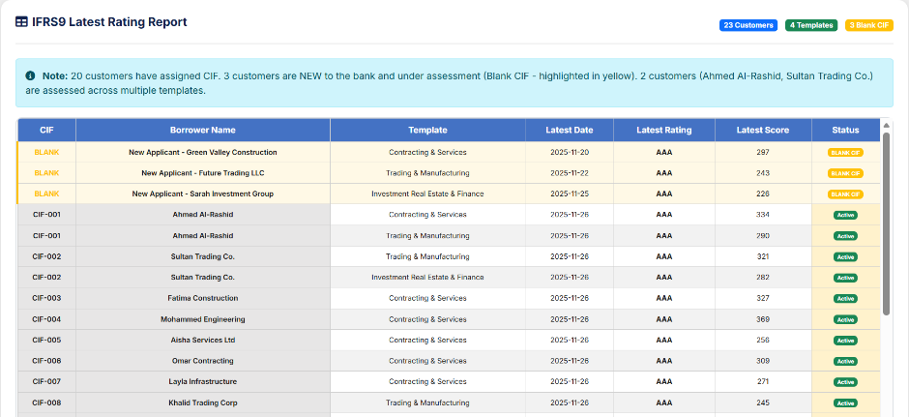
Each row corresponds to one customer (CIF) and shows the scores assigned across all qualitative, quantitative, and mandatory adjustment parameters defined in the model.
1. Customer Information
- CIF – Customer Identification File number (unique customer ID)
- Name – Customer name
These identify the customer for whom the assessment is performed.

2. Qualitative Parameters (Company & Business Factors)
The first set of columns captures non-financial, qualitative factors that influence customer risk. Examples:
- Constitution & Establishment – Type of entity (Govt, Public Co., Partnership, etc.)
- Number of Years in Business
- Credit Line Utilization with Other Lenders
- Financial Planning / Internal Controls
- Market Position
- Sector Contracting (Govt./Private Sector)
- Sensitivity to Economic Shocks
- Contractor Grade
- Past Track Record
- Competition & Demand
- Availability of Qualified Resources
Each factor shows a score based on predefined risk weight tables.

3. Quantitative Parameters (Financial Ratios)
The green columns reflect financial ratio scoring, including:
- Affiliate Due to Net Worth
- Current Ratio
- Debt-Equity Ratio
- Operating Revenue / External Liabilities
- Investment Assets to Total Assets
- Net Profit Margin
- Working Capital Turnover
- Change in Debt Ratio
These values are calculated using customer’s financial statements and mapped to the scoring ranges you provided earlier.
In this screenshot, financial numbers appear as NA, meaning:
- Financials were not available OR
- Customer belongs to a purely qualitative model OR
- This is sample dummy data

4. Miscellaneous Factors
These additional risk elements include:
- Account Conduct – Evergreen accounts, repayment behavior
- Economic Shock Factors – Sensitivity to market downturns, oil price crash, etc.
- # of Notches – Adjustment for overrides (manual upgrades/downgrades)
These influence the overall score when applicable.

5. Mandatory Adjustments
Mandatory risk modifiers include:
- Age of Financial Information
- Quality of Financial Information
- Historical Account Performance
- Qualification of Audit Report
These ensure that low-quality or outdated financials penalize the final outcome.

6. Final Score
The final column provides the total aggregated score after:
Qualitative score
Quantitative score
Miscellaneous
Mandatory Adjustments
In the example:
- CIF 001 → Final Score = 128
- CIF 002 → Final Score = 233

CIF Based Report
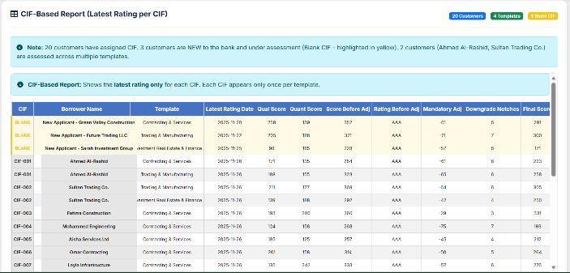
Interval Based Report
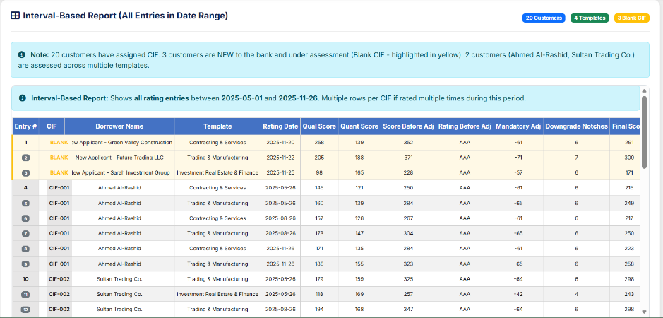

Client Additions -
Sample reports will be provided for all customers across all models with their respective scores.
Consolidated List of Client Requirements for the Reporting Module
1. Detailed Report Requirements
- The report must include the borrower’s Name and CIF.
- The report must display actual financial ratios, quantitative scores, and qualitative scores for each rating template.
- The report must show Score Before Mandatory Adjustment and Rating Before Mandatory Adjustment.
- The report must capture and display the Mandatory Adjustment Parameter and the respective Downgrade Notch.
- The report must show the Rating After Mandatory Adjustment.
- The report must include the Type of Overrides Applied (if any).
- The report must provide the Final Rating after Overrides for each rating template.
2. Historical Rating Requirements
- The system shall store the entire rating history of each borrower.
- When a report is generated for a selected date range, all historical rating events must be included if multiple ratings exist for the same borrower within that interval.
3. Blank CIF Reporting
- For borrowers without CIFs, the system must generate a Blank CIF Report showing:
  - Rating date
  - Borrower name
  - CIF (blank)
  - Other rating details
- The system must maintain logs for all CIF updates, to allow later alignment with iCBS once CIFs are assigned.
4. Default Rating Workflow
- The system must support marking a borrower as Defaulted using a dedicated field (“Borrower Defaulted”).
- When default is marked, the system must create a new rating event with rating D or 9/10/11, and deactivate all other rating parameters.
- Reports generated for any selected period must show the full rating chronology, e.g., 5 → 6 → 7 → D, with all corresponding details.
5. CIF-Based & Interval-Based Reports
- The system must support a CIF-Based Report, showing the latest rating for each CIF (one row per CIF).
- The system must support an Interval-Based Report, showing all rating entries within the chosen date range (multiple rows per CIF if applicable).
6. Periodic Historical Portfolio Report
- The system must support a Periodic Historical Final Score & Rating Report, displaying:
  - Score and Rating at each selected time interval (e.g., Dec 2022, Mar 2023, Jun 2023)
  - One row per CIF with multiple time-point columns.

7. IFRS9 “As On Date” Latest Rating Report
- The system must generate a report showing Latest Rating As On a Specific Date (e.g., 31 Dec 2024).
Required fields:
  - CIF
  - Customer Name
  - Rating Template
  - Score
  - Rating
  - Rating Date
The report must be downloadable in Excel/PDF formats.

4.7. Administration

4.7.1. Role Management
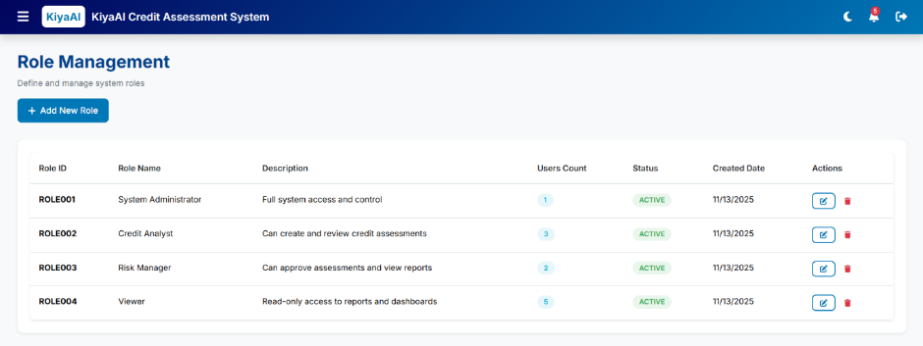
The Roles module enables administrators to create and manage user roles within the application.
Each role defines a set of permissions that control access to modules, screens, and actions across the system.
It forms the foundation of RBAC (Role-Based Access Control).
The Role Management screen displays:
A. Roles List Table
Includes:
- Role ID
- Role Name
- Role Type (System / Custom)
- Description
- Status (Active / Inactive)
- Actions (Edit, Activate/Deactivate)
B. Add/Edit Role Modal
Fields:
- Role Name
- Description
- Role Status
- Permissions Assignment (linked with RBAC module)
- Save / Cancel buttons

FUNCTIONAL DETAILS
Create Role
- Admin enters:
  - Role Name (e.g., Analyst, Reviewer, Admin)
  - Description
  - Status
- Saves role to system.
- Default roles may be predefined (e.g., System Admin).

Edit Role
- Admin can update:
  - Name
  - Description
  - Status
- Permissions edited via the RBAC module.

Role Status Management
- Active roles available for assignment.
- Inactive roles cannot be assigned.
- Audit logs maintained for status changes.

Permissions Integration
- Role definition alone does not grant access.
- Permissions must be linked in RBAC Module.
- Each role maps to modules, screens, or actions.

Validation Rules
- Role name must be unique.
- Cannot deactivate role if users are actively assigned (unless allowed by business).

4.7.2. User Management
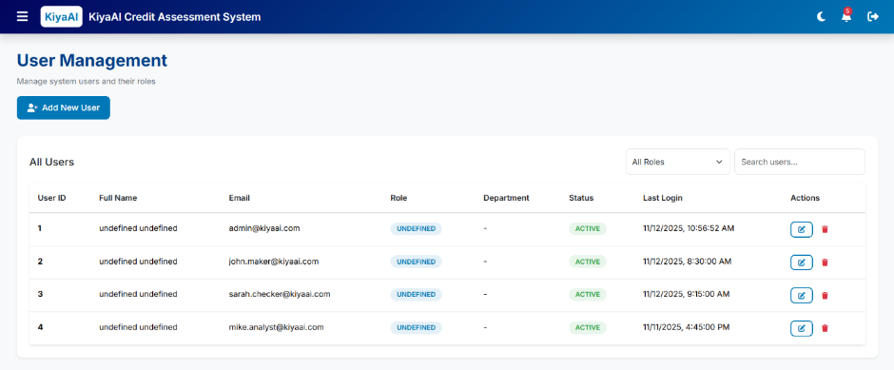

The User Management module enables administrators to create, update, and maintain user accounts for the KiyaAI Credit Assessment System.
It defines user identity, assigned roles, access levels, and operational status.
This module ensures secure and controlled access of users across the system.
The User Management screen includes:
A. User List Table
Columns:
- User ID
- Name
- Email
- Role
- Status (Active / Inactive / Locked)
- Last Login
- Actions (Edit, Activate/Deactivate, Reset Password)
B. Add/Edit User Form/Modal
Fields:
- Full Name
- Email Address
- Phone Number (optional)
- Role Assignment (dropdown)
- User Type (ADS / Manual Login)
- Status
- Optional: Department / Location
- Save / Cancel
C. Optional Actions
- Reset Password (Manual login users)
- Unlock User (after failed attempts lockout)
- Deactivate Account

FUNCTIONAL DETAILS
Create User
- Admin enters user details.
- Selects Role from Role Management module.
- Selects login type:
  - ADS User → Authenticated through Active Directory
  - Manual User → Password generated and sent via email
- Saves user into system.

Edit User
- Admin updates user details:
  - Name
  - Email
  - Role
  - Status
- Critical fields like email may be restricted depending on business rules.

User Status Management
Statuses include:
- Active → User can log in
- Inactive → User blocked from login
- Locked → System-locked due to failed attempts
Admin can:
- Unlock user
- Activate / Deactivate account

Password & Authentication Handling
For Manual Login Users:
- Admin can reset password
- User receives system-generated credentials
- User must change password on first login (optional requirement)
For ADS Users:
- Password managed in Active Directory
- No reset option inside system

Audit Trail Integration
System logs:
- User creation
- Updates
- Role changes
- Status changes
- Login attempts
- Failed login events

4.7.3. RBAC (Role-Based Access Control)
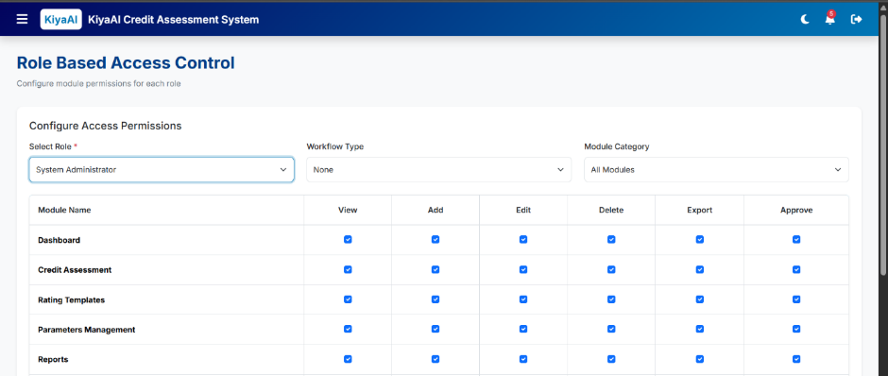
The RBAC (Role-Based Access Control) module defines permissions and access rights for each role in the system.
It determines what every role can view, edit, create, approve, or delete across modules.
RBAC ensures users only access features relevant to their responsibilities.
The RBAC screen includes:
A. Role Selection Panel
- Dropdown listing all active roles
- Selecting a role loads its current permissions
B. Permissions Matrix
Displayed in a table/grouped list:
- Modules (Dashboard, Assessment, Templates, Parameters, Reports, Admin, etc.)
- Submodules and screens
- Action-level controls, such as:
  - View
  - Create
  - Edit
  - Approve
  - Delete
  - Download Reports
  - Manage Workflow
Each permission uses toggle switches or checkboxes.
C. Save Permissions
- Button to persist changes for the selected role.

FUNCTIONAL DETAILS
Permission Assignment
For each role, admin can enable/disable access to:
- Entire modules
- Specific screens
- Field-level or action-level permissions (if configured)
Example:
- Analyst → View + Edit Assessments
- Reviewer → View + Approve Assessments
- Admin → Full Access

Permission Types
Common permission categories:
- Module Access (visibility in sidebar)
- Screen Access
- Create/Edit/Delete
- Approval Rights
- Report Generation
- Admin-Level Controls

Enforcement Mechanism
- Permissions are stored against each role.
- At login:
  - System loads user's role and permission set
  - Sidebar and screens dynamically adjust
- Actions blocked by API if unauthorized.

Integration with User Management
- Users inherit permissions from assigned roles.
- Role change automatically updates user access.

Audit Tracking
System logs:
- Permission modifications
- Modified by
- Timestamp

4.8. Masters

4.8.1. Lookup Management
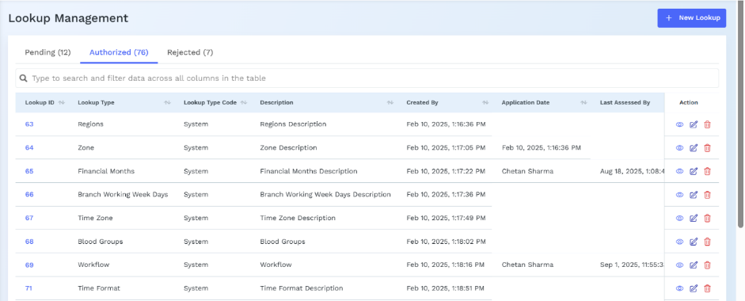

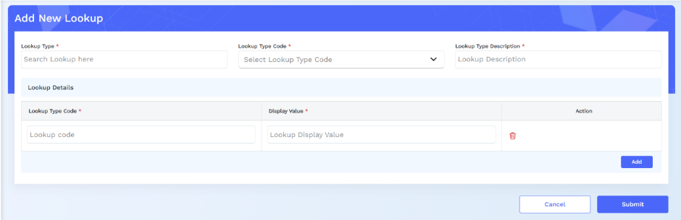

The Lookup Management module allows administrators to maintain all static and reusable dropdown values used across the system.
These lookups ensure consistency in data entry and support configurable options across multiple modules (Assessment, Templates, Parameters, Reports, etc.).
The Lookup Management screen includes:
A. Lookup Category List
Examples:
- Industry Category
- Entity Type
- Business Risk Options
- Qualitative Score Options
- Assessment Status
- Document Types
- Rating Grades
- Financial Ratio Types
B. Lookup Value Table
Columns:
- Lookup ID
- Lookup Name
- Display Value
- Status (Active/Inactive)
- Actions (Edit/Delete)
C. Add/Edit Lookup Modal
Fields:
- Category
- Lookup Name
- Display Value
- Description (optional)
- Status
- Save/Cancel buttons

FUNCTIONAL DETAILS
Create Lookup
- Admin selects a category or creates a new category.
- Adds lookup name and display value.
- Saves to system for immediate availability.

Edit Lookup
- Modify existing lookup:
  - Name
  - Display value
  - Status
- Deactivated lookups stop appearing in dropdowns.

Lookup Categories
Each category groups related values. Examples:
- Industry Sector for Entity Details
- Template Categories for Rating Templates
- Qualitative Options for Parameters
- Assessment Status Types for workflow

System Usage
Lookups populate:
- Dropdowns
- Filter lists
- Auto-complete inputs
- Validation reference data
Changes reflect across modules instantly.

Validation Rules
- Lookup name must be unique within its category.
- Category cannot be deleted if values exist.
- Inactive values cannot be assigned in new records.

4.9. System Configuration

The System Configuration module allows administrators to manage global system settings that impact communication, module visibility, and operational behavior.
It includes configuration of Email Server, Email Templates, and Module Management.

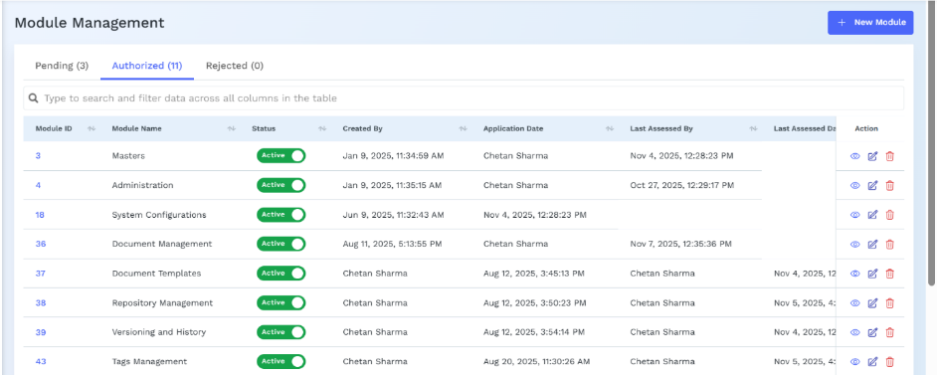

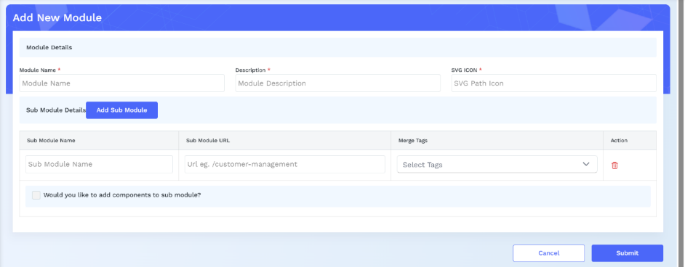

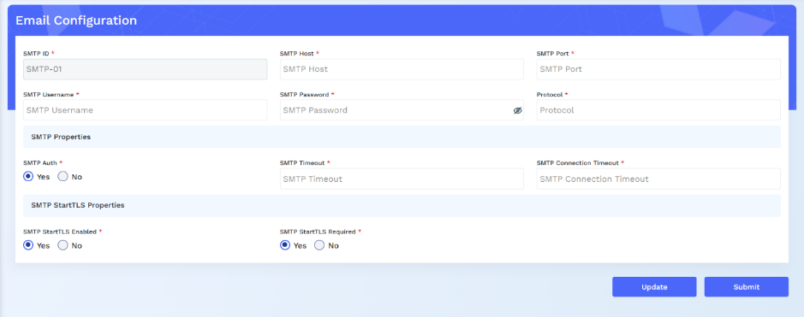

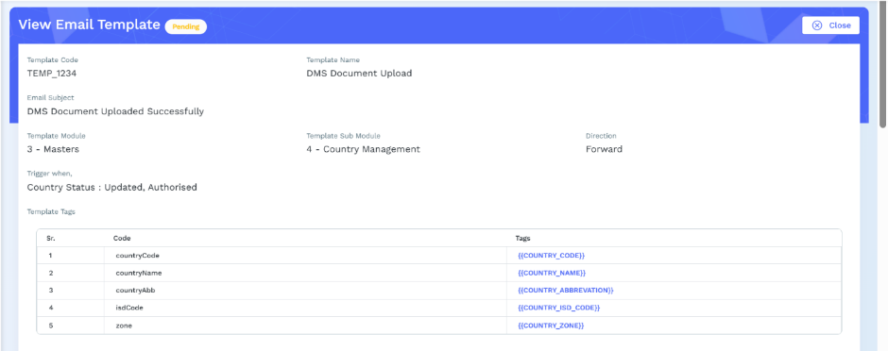
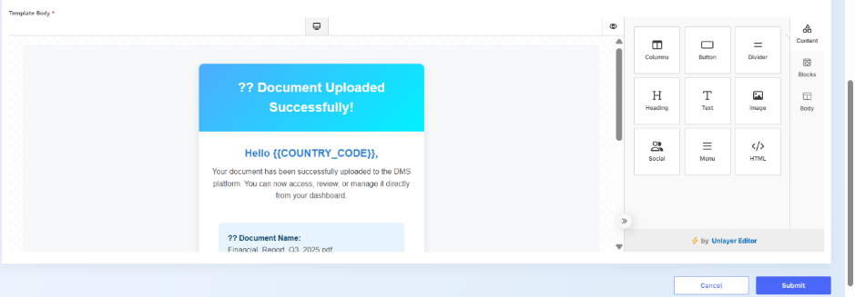

A. Email Configuration
Fields:
- SMTP Server
- Port
- Sender Email (From Address)
- Username
- Password / App Key
- SSL/TLS Enable Toggle
Email Configuration
- Admin enters SMTP details required for system notifications.
- “Test Email” validates configuration.
- Used for:
  - User creation emails
  - Password reset
  - Assessment alerts
  - Report delivery (if applicable)
Validation:
- Mandatory fields must be valid before save.

B. Email Templates
Columns:
- Template Name
- Subject
- Type (Password Reset, Notification, Assessment Report, Alerts)
- Actions (Edit/Preview)
Add/Edit Template Modal:
- Template Name
- Subject Line
- Body (Rich Text Editor)
- Dynamic Variables (e.g., {{UserName}}, {{AssessmentId}})
- Admin manages system-generated email formats.
- Templates support placeholders for dynamic data.
- Typical templates:
  - User Onboarding
  - Password Reset
  - Assessment Completed
  - Approval Notifications
Editing:
- Admin updates subject and body via rich text editor.
- Preview option before save.

C. Module Management
- Toggle-based list of modules:
  - Dashboard
  - Credit Assessment
  - Templates
  - Parameters
  - Reports
  - Audit
  - Admin Modules
- Admin can enable/disable modules for all users or selected roles (if extended).

Controls which modules appear in the sidebar.
Disabling a module hides it from all users (unless role-based override is configured).
Helps manage phased rollouts or features under development.

5. Data Ingestion

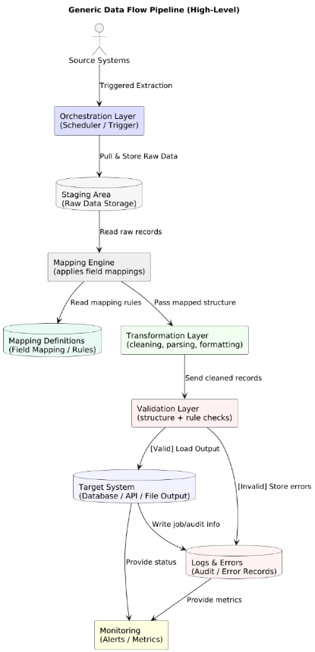

High-Level Stepwise Summary
1. Extract
Data is pulled from source systems (DB, API, files) based on a trigger or schedule.
2. Stage
Raw data is stored temporarily without changes, to keep an untouched copy.
3. Map
A mapping engine reads mapping definitions and aligns source fields to target fields.
4. Transform
Mapped data is cleaned, formatted, and converted into the required structure.
5. Validate
Data is checked for correctness, mandatory fields, formats, and business rules.
6. Load
Valid data is loaded into the target system (database, file, API, etc.).
7. Log & Error Handling
Invalid data and process errors are recorded for debugging or reprocessing.
8. Monitor
System monitors job status, performance, and alerts on failures or anomalies.

Financial Data Ingestion & Auto-Population
The Credit Assessment System requires complete and accurate financial information to calculate ratios, scores, and the final borrower rating.
Since the Core Banking System (CBS) does not store detailed financial statements, the system supports three user-friendly methods to bring audited financial data into the rating workflow:
- Excel Upload (Primary & Preferred Method)
- OCR Upload (PDF/Image Recognition)
- Manual Entry (Fallback Method & NEW Customers)
Regardless of the method used, the system automatically fills the financial forms, computes all ratios using predefined formulas, and calculates the final rating in real-time.
A. What Data Comes From CBS
When the user enters a CIF, the system automatically fetches the following CBS information:
- Customer Name
- Entity Type
- Industry / Sector
- CINET number
- Customer Status (Active, Closed, etc.)
- Loan Accounts (Account ID, Type, Sanctioned Limit, Outstanding, Overdues)
- Collateral Details (if available)
CBS does NOT provide: Revenue, Assets, Liabilities, EBITDA, Inventory, Profit, Borrowings break up, etc.
These must come from Excel/OCR or manual entry.
CBS data is used only to identify the customer and show current exposure.

B. Staging Area Approach
Because CBS is owned by another vendor, all CBS data first comes into a secure staging area before being used.
Functionally, the staging area works like a mailbox:
- CBS places customer and loan data in the staging folder.
- The credit system picks the files from staging.
- System fills customer details automatically in Step-1 of the Assessment.
The staging area ensures:
- Clean separation between CBS and our system
- Full audit trails
- Simple, secure data exchange
- No need for CBS vendor changes

C. Excel Upload – Primary Method for Financial Statements
This is the main method used by the bank because Excel provides the cleanest audited values.
Step-by-Step Functional Flow
- User uploads the bank’s standard Excel template.
- System checks:
  - Is format correct?
  - Are all required fields present?
  - Are the numbers valid?
- System reads every financial value from the Excel:
  - Revenue
  - COGS
  - EBITDA
  - Net Profit
  - Current Assets / Liabilities
  - Inventory
  - Receivables / Payables
  - Short-term & Long-term Borrowings
  - Total Assets / Liabilities
  - Equity
  - Interest Expense
- System automatically fills all these values into:
  - Balance Sheet Section
  - Profit & Loss Section
  - Cash Flow Section (if available)
- User does NOT need to type anything manually.
- All fields remain editable so the analyst can correct or adjust values.

D. OCR Upload – If Excel Is Not Available
If the user uploads a PDF or scanned image of financial statements:
- The OCR engine reads values directly from the PDF.
- Extracted values appear on screen for review.
- User can correct any mistakes.
- Once confirmed, the system treats it the same as Excel upload.
OCR ensures the bank can still proceed with assessments even if the customer only gives a PDF.

E. Manual Entry – Fallback Method
If no Excel or PDF is available:
- User manually enters financial values.
- System immediately calculates ratios & scoring.
- All inputs remain editable.
This ensures assessments can continue without delay.

F. Auto-Population of Assessment Form
Once financial data is received through Excel, OCR, or manual entry, the system:
1. Automatically fills:
- Balance Sheet
- P&L Statement
- Cash Flow Statement
- Financial Projections (if enabled)
- All parameter values used in the rating template
2. No retyping required
Every financial input field is pre-filled.
3. Every field remains editable
If the analyst changes any number:
- All ratios update instantly
- All scores recalculate automatically
- Final rating adjusts in real time

G. Ratio Calculation – Explanation
The system uses standard banking formulas.
Examples:
Current Ratio
= Current Assets ÷ Current Liabilities
Quick Ratio
= (Current Assets – Inventory) ÷ Current Liabilities
Debt/Equity Ratio
= Total Debt ÷ Shareholder Equity
Interest Coverage Ratio
= EBITDA ÷ Interest Expense
Working Capital Cycle
= Receivable Days + Inventory Days – Payable Days
All these values are calculated automatically by the system.
No user calculation is required.

H. Scoring & Final Rating – Simple Explanation
- Each ratio has a scoring rule based on bank thresholds.
Example:
  - Current Ratio > 2.0 → Score: 4
  - Current Ratio < 1.0 → Score: 1
- Each parameter has weightage defined in the Rating Template.
Example:
  - Current Ratio Weight = 5%
  - Profitability Weight = 10%
- System applies the weightage to each score.
- Total weighted score is calculated.
- Final Score maps to rating grade (A+, A, BBB, BB, etc.)
This calculation is fully automated.
I. Editable Inputs & Audit Trail
Editable Inputs
- All imported values (Excel/OCR)
- All manually entered values
- All projected values
Non-Editable Inputs
- System-calculated ratios
- System-calculated weighted scores
- Final rating grade (unless adjusted in “Manual Adjustment Layer”)

J. End-to-End Example (Functional)
- User enters CIF → system fetches customer info from CBS.
- User uploads Excel for FY 2023.
- System reads all 50+ financial fields.
- System fills the entire financial form automatically.
- System calculates:
  - 15+ ratios
  - Section scores
  - Weighted contributions
  - Final credit rating
- User edits one value (e.g., Inventory).
- System instantly recalculates ratios, scores, and rating.
- User submits assessment for approval.
- System stores a complete snapshot for audit.

K. Why This Approach Works for the Bank (Business Benefits)
- No dependency on CBS for financials
- No manual calculations needed
- Faster assessment turnaround
- Cleaner, standardized financial data
- All ratios & ratings fully automated
- Supports Maker–Checker–Approver workflow
- Full audit trail for compliance
- Supports both new and existing customers
- Supports projections & forecasting
- Works even when only PDFs exist (OCR fallback)

MASTER FINANCIAL RATIO TABLE
Ratio Name | Formula | Required Fields | Category | Bank Requires  Yes/No
Current Ratio | Current Assets / Current Liabilities | Current Assets, Current Liabilities | Liquidity
Quick Ratio | (CA – Inventory) / CL | Current Assets, Inventory, Current Liabilities | Liquidity
Cash Ratio | Cash & Equivalents / CL | Cash & Cash Equivalents, Current Liabilities | Liquidity
Working Capital | CA – CL | Current Assets, Current Liabilities | Liquidity
Working Capital Ratio | WC / Total Assets | Current Assets, Current Liabilities, Total Assets | Liquidity
Debt to Equity | Total Debt / Equity | Short-Term Borrowings, Long-Term Borrowings, Equity | Leverage
Total Liabilities to Total Assets (TLTA) | Total Liabilities / Total Assets | Total Liabilities, Total Assets | Leverage
Debt/EBITDA | Total Debt / EBITDA | Short-Term Borrowings, Long-Term Borrowings, EBITDA | Leverage
Debt/Capital | Total Debt / (Debt + Equity) | Total Debt, Equity | Leverage
Interest-Bearing Debt Ratio | Interest-Bearing Debt / Total Assets | Interest-Bearing Debt, Total Assets | Leverage
Interest Coverage Ratio (ICR) | EBITDA / Interest Expense | EBITDA, Interest Expense | Leverage
Fixed Charge Coverage Ratio (FCCR) | (EBITDA – CAPEX) / (Interest + Principal Due) | EBITDA, CAPEX, Interest Expense, Principal Due | Leverage
LT Debt to Capitalization | LT Borrowings / (LT Borrowings + Equity) | LT Borrowings, Equity | Leverage
Gross Profit Margin | (Revenue – COGS) / Revenue | Revenue, COGS | Profitability
EBITDA Margin | EBITDA / Revenue | EBITDA, Revenue | Profitability
Operating Margin (EBIT Margin) | EBIT / Revenue | EBIT, Revenue | Profitability
Net Profit Margin | NPAT / Revenue | NPAT, Revenue | Profitability
ROA | NPAT / Total Assets | NPAT, Total Assets | Profitability
ROE | NPAT / Equity | NPAT, Equity | Profitability
ROCE | EBIT / (Total Assets – CL) | EBIT, Total Assets, Current Liabilities | Profitability
ROIC | NOPAT / Invested Capital | NOPAT, Invested Capital | Profitability
Asset Turnover | Revenue / Total Assets | Revenue, Total Assets | Profitability
Inventory Turnover | COGS / Inventory | COGS, Inventory | Efficiency
Receivables Turnover | Revenue / AR | Revenue, Accounts Receivable | Efficiency
Payables Turnover | COGS / AP | COGS, Accounts Payable | Efficiency
Receivable Days | (AR / Revenue) × 365 | Accounts Receivable, Revenue | Efficiency
Inventory Days | (Inventory / COGS) × 365 | Inventory, COGS | Efficiency
Payable Days | (AP / COGS) × 365 | Accounts Payable, COGS | Efficiency
Working Capital Cycle | Rec Days + Inv Days − Pay Days | AR, Inventory, AP, Revenue, COGS | Efficiency
Fixed Asset Turnover | Revenue / Net Fixed Assets | Revenue, Net Fixed Assets | Efficiency
Capital Employed Turnover | Revenue / Capital Employed | Revenue, Capital Employed | Efficiency
CFO to Debt | CFO / Total Debt | CFO, Total Debt | Cash Flow
Cash Conversion Ratio | CFO / EBITDA | CFO, EBITDA | Cash Flow
Free Cash Flow | CFO − CAPEX | CFO, CAPEX | Cash Flow
FCF to Debt Service | FCF / (Interest + Principal) | FCF, Interest Expense, Principal Due | Cash Flow
DSCR | (EBITDA − Taxes − WC Changes) / (Interest + Principal) | EBITDA, Taxes, WC Changes, Interest, Principal Due | Cash Flow
Operating Cash Flow Ratio | CFO / Current Liabilities | CFO, Current Liabilities | Cash Flow
Equity Ratio | Equity / Total Assets | Equity, Total Assets | Capital Structure
Debt Ratio | Total Debt / Total Assets | Total Debt, Total Assets | Capital Structure
Financial Leverage Index | ROE / ROA | ROE, ROA | Capital Structure
Contract Profitability Ratio | Contract Profit / Contract Revenue | Contract Profit, Contract Revenue | Contracting
Cost to Complete (%) | Remaining Cost / Total Estimated Cost | Remaining Cost, Total Estimated Cost | Contracting
Billing Efficiency | Billed Amount / Work Completed | Billed Amount, Work Completed | Contracting
Order Book to Revenue | Order Book / Revenue | Order Book, Revenue | Contracting
Advance Utilization | Unutilized Advances / Total Advances | Unutilized Advances, Total Advances | Contracting
Lender’s Case DSCR | CFA / Debt Service | Cash Flow Available, Debt Service | Project Finance
Interest Reserve Coverage | Interest Reserve / Interest Requirement | Interest Reserve, Interest Requirement | Project Finance
Bank Turnover Ratio | Bank Turnover / Sales | Bank Turnover, Revenue | SME/MSME
GST Turnover Ratio | GST Turnover / Audited Turnover | GST Turnover, Audited Turnover | SME/MSME
Promoter Contribution Ratio | Promoter Contribution / Project Cost | Promoter Contribution, Project Cost | SME/MSME
Net Working Capital Gap | WC Requirement − NWC | WC Requirement, Net Working Capital | SME/MSME
Revenue Growth % | (CY Revenue − PY Revenue) / PY Revenue | Current Year Revenue, Previous Year Revenue | Growth
Profit Growth % | (CY NPAT − PY NPAT) / PY NPAT | NPAT CY, NPAT PY | Growth
EBITDA Growth % | (CY EBITDA − PY EBITDA) / PY EBITDA | EBITDA CY, EBITDA PY | Growth
Asset Growth % | (Assets CY − Assets PY) / Assets PY | Total Assets CY, Total Assets PY | Growth
Security Coverage Ratio | Realizable Security Value / Outstanding Exposure | Realizable Security Value, Outstanding Exposure | Risk
Loan-to-Value (LTV) | Loan Amount / Asset Value | Loan Amount, Asset Value | Risk
DP Utilization | Outstanding / Drawing Power | Outstanding, Drawing Power | Risk
Limit Utilization | Avg Utilization / Sanction Limit | Average Utilization, Sanction Limit | Risk

6. API Catalogue

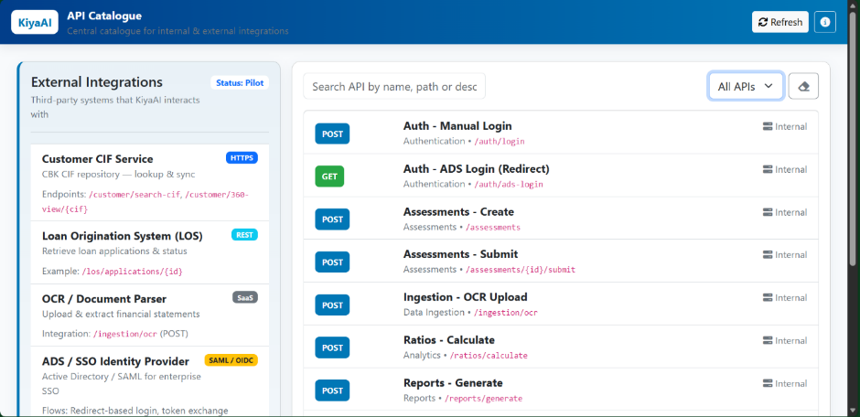

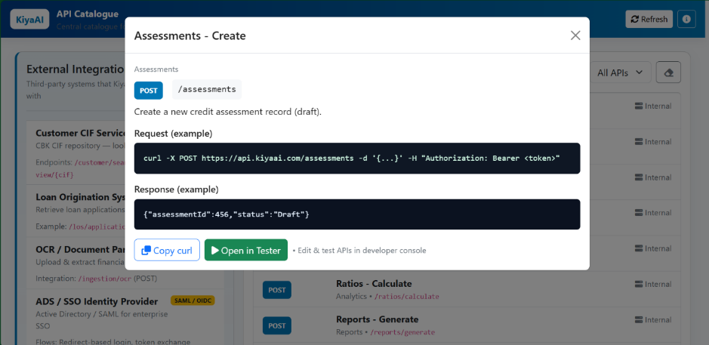

The API Catalog defines all backend services that the KiyaAI Credit Assessment System exposes or consumes.
These APIs are used by the frontend, admin modules, workflow engine, data ingestion components, and external systems where integration is required.
APIs ensure that all modules interact consistently and securely through REST-based communication.

The API Catalogue dashboard consists of the following sections:
A. External APIs Panel
This section lists all third-party or client-owned systems integrated with the solution.
Each external API displays:
- API/System Name
- Integration Type (REST, SOAP, SAML, OIDC, SMTP, etc.)
- Base URL / Endpoint Pattern
- Purpose (e.g., CIF Search, Document Parsing, SSO Authentication)
- Example Endpoints
The catalogue highlights:
- Endpoint Paths
- Supported HTTP Methods
- Functional Purpose
- Input Requirements
- Output Structure
- Authentication/Headers
- Dependencies
- External System Mapping

7. Deployment Mechanism

The system supports modern deployment methodologies that ensure reliable and repeatable releases.
A. Deployment Architecture
- 3-Tier Architecture
  - Frontend (Angular)
  - Backend (Spring Boot)
  - Database (MS-SQL/Oracle)
B. Deployment Models Supported
- On-Premises Deployment (Preferred by CBK)
- Cloud Deployment (Optional)
  - Private cloud / Containerized
  - Docker + Kubernetes-enabled (optional)
INFRASTRUCTURE REQUIREMENTS
A. Hardware Requirements
(Indicative, can be adjusted based on load)
Layer | Specification | Recommendation
Frontend Server
Backend Server
Database Server
File Storage

B. Operating Systems
- Windows Server – Recommended for ADS integrations

C. Network & Connectivity
- HTTPS enabled
- SSL certificate (internal or public CA)
- Secure VPN/IP Whitelisting for external integrations
- Firewall rules for API communication

8. Software Pre-requisites

Will be shared by the KiyaAI Team during the Deployment Phase.

8.1. ENVIRONMENT SETUP
The solution will run across 3–4 environments:
Environment | Purpose
DEV | Developer testing
TEST / QA | Internal testing + automation
UAT | Client validation (CBK)
PRODUCTION | Live environment
Each environment mirrors production as closely as possible.

9. Project Documentation

The Project Documentation section lists all key documents that support the development, implementation, and ongoing use of the KiyaAI Credit Assessment System.
These documents ensure that stakeholders—from business users to technical teams—have the necessary clarity for system understanding, maintenance, and onboarding.

A. Functional Specification Document (FSD)
Purpose
The FSD provides a detailed functional description of every module, workflow, and business rule defined in the BRD.
It translates business requirements into actionable functional behaviours for development teams.
Contents
- Module-level functional descriptions
- Field-by-field specifications
- User interactions and system responses
- Workflow logic (including maker–checker, approvals, and validations)
- Error messages and exception handling
- Business rules, scoring logic, ratio formulas
- Integration specifications with CIF/LOS/OCR/ADS
- UI wireframes (if applicable)

B. User Manual
Purpose
The User Manual guides end-users in operating the system effectively. It includes navigation flows, screenshots, and instructions for daily activities.
Contents
- Login instructions (Manual + ADS)
- Using the Dashboard
- Creating and managing assessments
- Uploading financial statements (OCR/Excel)
- Ratio interpretation
- Viewing and generating reports
- Template and parameter management
- Admin activities (User, Roles, RBAC, Lookups)
- Troubleshooting and FAQs
Audience
- Analysts
- Reviewers
- Administrators
- Risk & Credit Teams
- Business Users

C. Deployment Guide
Purpose
The Deployment Guide provides step-by-step instructions for setting up and deploying the system in different environments.
Contents
- Prerequisites
- Required software and tools
- Server configuration steps
- Database setup (Oracle schemas, tables, seeds)
- Environment variable configuration
- Email and OCR configuration
- How to deploy frontend & backend builds
- Log configuration and monitoring setup
- Rollback strategies
- Post-deployment validation checklist
Audience
- IT Infrastructure Teams
- DevOps Teams
- System Administrators

-----------END OF THE DOCUMENT-----------

